ST JOSEPH’S COLLEGE (AUTONOMOUS), BANGALORE – 27
Register Number:
Date:
BVOC (DIGITAL MEDIA AND ANIMATION) – IV SEMESTER
END SEMESTER EXAMINATION – JULY 2022
VOA 4119: Web Development

Time: 2 ½ Hours Max Marks: 70
This question paper has TWO printed page and THREE parts.

- Fill in the blanks (10X1=10)
  - The Arithmetic operator for addition is ____, for subtraction ______, for multiplication _______, for division ________, for exponentiation _________, and for modulus _________.
  - In Python, comments begin with: ________
  - When Python is run from the command prompt, and the commands are entered and executed directly in the window, Python is said to be in __________ mode.
  - The _______ keyword is used to make a function return a value.
  - The order of evaluation of arithmetic operations, also called the order of operations is ________, _________, _________, ________, _______, and _________. The acronym is ________.
  - A boolean expression is one that is either ______ or _______.
  - Dictionaries contain _____________ pairs.
  - Lists are _______, which means the values in a list can be changed.
  - One can assign values to an instance of a class using ______ notation. These values are called __________.
  - The _______ method is a special method that gets invoked when an object is instantiated.
- Answer any Three of the following in about 150 words each. (3X10=30)
  - What is an embedded or internal stylesheet? Explain with examples 3 ways to add a stylesheet to a webpage.
  - Give the html code for a form that looks like the below image. Include a form handler URL and any other required attributes.
  - Give the CSS and HTML code for a multi-column layout as below:
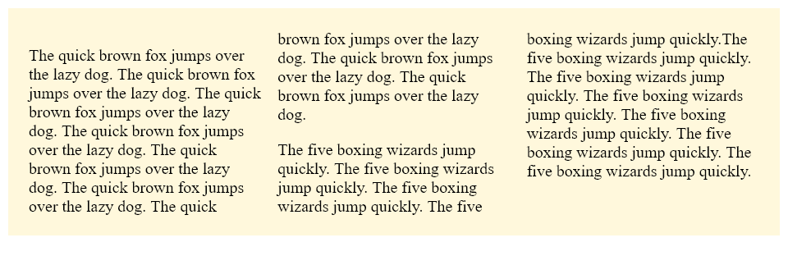
  - Give 5 CSS font properties with example declarations for each.

- Answer any THREE of the following questions in around 150 words each. (3x10=30)

  - In what kind of projects is UX design given importance? Give brief descriptions of the types of projects.
  - What is design thinking? Explain the 5 phases of design thinking with suitable examples.
  - Describe five UX research techniques.
  - Write a function in Python that takes two string arguments. The function should concatenate (join) the two strings and display them on the screen 10 times.
  - Write a function in Python that takes two integer arguments. The function should compare the two integers and display one of the following messages: “The first number is greater than the second number” or “The first number is smaller than the second number” or “The two numbers are equal”, as appropriate. Also, the function should display the difference between the two numbers with the message “The difference between the two numbers is:”

VOA4119_22_B

