
Register Number:
DATE:

ST. JOSEPH’S COLLEGE (AUTONOMOUS), BANGALORE-27
B.Sc. ELECTRONICS – IV SEMESTER
SEMESTER EXAMINATION- APRIL 2022
(Examination conducted in July 2022)
EL 418- Verilog HDL

Time: 1 ½ hrs Max marks: 35
This question paper has TWO printed pages and THREE parts.
PART – A
ANSWER ANY THREE OF THE FOLLOWING 3X5=15
1. With example explain Top-down design methodology in Verilog HDL.

2. Define System task. Explain $stop and $monitor system tasks.

3. a) Write a note on delays in data flow modeling.
b) With example explain case statement. (3+2)

4. With example explain blocking and Non-blocking assignment statements.

5. Give any five differences between task and function.

PART – B
ANSWER ANY THREE OF THE FOLLOWING 3x6=18
6. Write a design (gate level) and test module to implement 4-bit ripple carry adder.

7. Write a design and test module for the given circuit:
.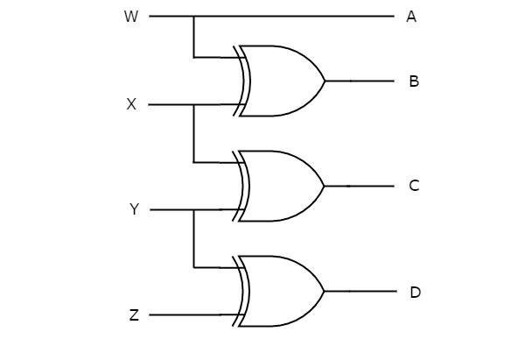

8 Write a design and test module to implement S R flip-flop using behavioral modeling.

9. Write a design and test module to implement 4 to 1 multiplexer using behavioral modeling.

10. Write a design and test module for 2-bit magnitude comparator.

PART – C
ANSWER ANY TWO OF THE FOLLOWING 2x1=02
11. Declare a vector to store 32 bit address.
12. Name the two ways of connecting ports in a module?
13. What is the value of Y
A = 1’b0, B = 2’b01, C = 2’b10
Y = { A, B[0], C[1] };

14. Write the general syntax for generate if statement.
*************************************************************************************************************

