Register Number:
Date:

ST. JOSEPH’S COLLEGE, BANGALORE – 27
END-SEMESTER EXAMINATION: DECEMBER 2022
III SEMESTER – L1 GE 322: GENERAL ENGLISH
PSA SPECIAL COURSE– SCIENCE AND THE MAKING OF MODERNITY
This paper contains THREE printed pages with Two Sections.

Time- 2 hours Max Marks- 60

Instructions:
1) This paper is for III semester students who have opted for the PSA Special course
2) Please write PSA Special on the front page of your answer booklet.
3) You are allowed to use a dictionary during the examination.
4) This paper contains TWO sections and THREE pages

I. Read this article from The Wire:
Science Has a Communication Problem – And a Connection Problem
According to the Pew Research Center, US adults that have a “fair amount” or a “great deal” of trust in scientists fell from 87% to 77% in just the past two years. Research has shown that simply giving the public more information isn’t the best way to correct this. It’s crucial that scientists find ways to communicate more effectively and directly with the public, so the public can have access to the minds, and hearts, of scientists. In other words, they need to see scientists as people whom they can empathise with and learn to trust.
At most top-tier research institutions, the primary responsibility of a scientist is to win more grants. Anything that supports that, for example, writing proposals and publishing well-received papers, is rewarded by the institution through promotion and tenure. On the flip side, anything that does not support that – including engaging in public communication – is often treated as a distraction.
Scientists can be quick to blame the media for poor science communication, but ultimately those stories wouldn’t exist without the scientists participating in the process: generating the research, assisting in their university’s press release process, and making themselves available for interviews.
For scientists who do want to communicate their work to the public, the media landscape can be tricky to navigate. While there are plenty of journalists who are careful to get the science right in their work, there are others in media whose interests don’t always align with scientists’ interests. Thus we see good science distorted into bad messages. When working with the media, scientists should verify the publishing history of the journalist and outlet they are working with, and, when possible, ask for a review of the quotes used in the piece. It’s worth noting though that many outlets do not allow for quotes to be reviewed verbatim in the interest of journalistic integrity. If that’s the case, scientists should request a fact-checker or editor contact them and provide a summary of the quotes provided.
Social media offers an unfiltered method of communication, where scientists can be more directly engaged with the public. While it requires scientists to devote time and energy to build a following, it should be leveraged more as an important tool in reaching people on a one-to-one basis. While the majority of scientists use social media, many of them use those platforms to connect with each other, rather than the public.
I.A. Answer the following questions in 150 words each: [3x10=30]
1. Do you think it’s a good idea for scientists to engage in public communication or should they focus on research, limiting their interactions to the scientific community? Corroborate your opinion.
2. Do you think that there’s any bit of advice or suggestions that the article has missed about the manner in which scientists associate with the media? Provide details.
3. “Research has shown that simply giving the public more information isn’t the best way to correct this (public perception of science)”. Do you think scientists can withhold information in the interest of safeguarding society and to prevent people from panicking? Discuss with at least one example.
II. Carefully examine this infographic about the Baloney Detection Kit
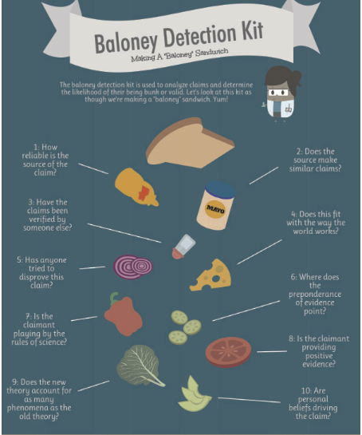
For a class project, a pair of 11th grade physics students created the infographic shown above, inspired by Michael Shermer’s Baloney Detection Kit: a 16-page booklet designed to hone your critical thinking skills. It includes suggestions on what questions to ask, what traps to avoid, specific examples of how the scientific method is used to test pseudoscience and paranormal claims, and a how-to guide for developing a class in critical thinking. It is used to analyse claims and determine the likelihood of their being bunk or valid. It constitutes ten basic questions to ask when encountering any claim:
- How reliable is the source of the claim?
- Does this source often make similar claims?
- Have the claims been verified by another source?
- How does the claim fit with what we know about how the world works?
- Has anyone gone out of the way to disprove the claim, or has only supportive evidence been sought?
- Does the preponderance of evidence point to the claimant's conclusion or to a different one?
- Is the claimant employing the accepted rules of reason and tools of research, or have these been abandoned in favour of others that lead to the desired conclusion?
- Is the claimant providing an explanation for the observed phenomena or merely denying the existing explanation?
- If the claimant proffers a new explanation, does it account for as many phenomena as the old explanation did?
- Do the claimant's personal beliefs and biases drive the conclusions, or vice versa?
II. A. Answer the following questions in about 200 words: [2x15=30]
- Do you consider the above infographic an attempt at science communication? Discuss why or why not.
- The above infographic is inspired by The Baloney Detection Kit: Carl Sagan’s Rules for Critical Thinking. Since the set of rules is not limited to the issue of demarcating science from pseudoscience, what other purposes can this guide be put to?
------------

