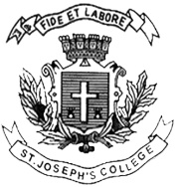
Register Number:
DATE:

ST JOSEPH’S COLLEGE (AUTONOMOUS), BANGALORE – 27
BA VISUAL COMMUNICATION – III SEMESTER
SEMESTER EXAMINATION: OCTOBER 2022
(Examination conducted in December 2022)
VC3122: INTRODUCTION TO FILM ARTS

Time- 2 hrs Max Marks-60
This paper contains ONE printed page and ONE part

- Answer any SIX questions in 300 words each: (6 x 10 = 60)

- Explain the different types of camera movements, their characteristics and meanings.
- What is sound editing? Explain ADR and Foley.
- Define any four editing transitions and explain their significance and functions.
- What are the different elements of mise-en-scene? Explain the significance of each of them by using relevant examples.
- Discuss in detail the Italian Neo-realist form and style using an example.

- Explain various characteristics of German expressionism film movement.
- Explain the film forms: narrative, documentary, experimental.
- What is montage theory? Explain how Soviet cinema used it in to create impact films.

VC3122_B_22

