Registration Number:
Date & session:
Registration Number:
Date & Session: 7-12-2022 ( 1pm )

ST.JOSEPH’S UNIVERSITY, BENGALURU -27
B.Sc. (BIOCHEMISTRY) – I SEMESTER
SEMESTER EXAMINATION: OCTOBER 2022
(Examination conducted in December 2022)
BCH 121– Inorganic and physical Chemistry

Time: 2 Hours Max Marks: 50
This paper contains 4 printed pages and 4 parts

PART-A
Answer any 11 of the following in a word or in a sentence. [1 X 11 = 11M]
- Between 5p and 6s orbital, which orbital will be filled first?
- For the formation of ionic bond ionization enthalpy should be greater or lower?
- Define molar heat of vaporisation.
- Write the Lewis structure of CO₂.
- Give an example of a common ion effect.
- Why are liquid drops spherical in shape?
- How viscosity and fluidity are related to each other?
- What is [OH⁻] at pH 0?
- Which is a stronger acid? (Given: pK_{a} of HClO₄ is -10 and that of HF is 3.2)
- What is the oxidation state of Cl in ClO⁻ ?
- The E⁰ of a cell was calculated to be +1.1V. Is this an electrochemical or electrolytic cell?
- State Raoult’s law.
- What is the reason for observing abnormal mass of a compound when it is determined based on colligative properties?

PART-B
Answer any 7of the following. [2 X 7 = 14M]
- Calculate the azimuthal quantum number (l) for K shell and to which subshell it belongs?
- Arrange the following in the increasing order of covalency
- NaF, NaBr, NaI and NaCl.
- LiF, RbF, NaF and KF.
- Write the resonance form of ozone (O₃).
- Write the mathematical form of Reynold’s number and explain how it is useful in deciding the type of flow?
- Diagrammatically represent the formation of bonding and antibonding molecular orbital for p-p overlap.
- Justify that a liquid on evaporation cools itself.
- How does a basic buffer resist the change in pH upon addition of small quantities of HCl?
- The solubility of gas increases or decreases with rise of temperature? Defend your answer.
- Calculate the emf of a cell with the notation, Zn_{(s)} |Zn²⁺_{(aq)} ||Cu²⁺_{(aq)} |Cu_{(s)}, given that E⁰ of Cu/Cu²⁺ = -0.34 V and E⁰ of Zn/Zn²⁺ = +0.76 V.

PART-C
Answer any5 of the following. [3 X 5 = 15M]
- Explain stability of half-filled subshells in terms of symmetry of orbitals by taking the example of chromium.
- Taking ethene as an example, explain sp² hybridization and also mention the types of bond formed.
- Explain why one can observe an elevation in boiling point on addition of a solute.
- Write the electronic configuration of:
(i) Na (11)
(ii) Cu (29)
(iii) I (53)
- Acetic acid (CH₃COOH) associates in benzene to form dimers, 4.65g of CH₃COOH when dissolved in 100g of C₆H₆ raised the boiling point by 0.36⁰C. Calculate Van’t Hoff factor and degree of association of CH₃COOH in C₆H₆.
- Derive Henderson-Hasselbalch equation for acetic acid.
- Write the half-cell reaction and the overall cell reaction for the electrochemical cell:
Zn | Zn²⁺ (1.0M) || Pb²⁺ (1.0M) | Pb.

PART-D

Answer any two of the following. [5 X 2 = 10M]
- (a) What are the values of quantum numbers n, l and m for the electron of highest energy in sodium (z = 11) atom?
(b) With proper reasoning arrange the following in increasing order of acid strength
CH₃COOH, CH₂FCOOH, CH₂FCH₂COOH (2 + 3)

- (a) Which of these species has a longer bond B₂ or B₂⁺? Explain. (Z of B is 5)
(b) Which one among the following is not likely to have a tetrahedral shape: SiBr₄, NF₄⁺, SF₄ and BF₄⁻? Explain your answer. (2 + 3)

- (a) In the given plot of E_{cell} vs. log Q, why does a change in log Q affect the E₀cell value? This cell comprises of 1M Cu²⁺; 1.0 × 10⁻⁶ M Zn²⁺ and eventually, the concentrations of Cu and Zn are reversed. Explain what could be occurring and how Q affects the E₀cell.
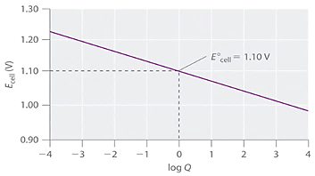
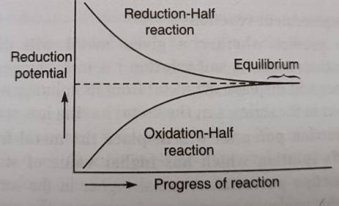
(b) The image given below depicts completion of the two half-reactions. How does this apply to batteries we use in everyday life and what happens to flow of current and E₀cell when equilibrium is attained? How does this apply to our own cells – i.e., what will happen if our cells attain equilibrium? (2+3)

