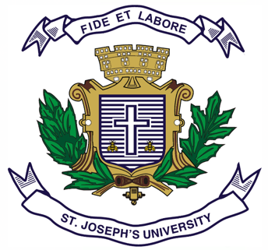
ST. JOSEPH’S UNIVERSITY, BENGALURU -27
Registration Number:
Date & session:
M.A(POLITICAL SCIENCE) – I SEMESTER
SEMESTER EXAMINATION: OCTOBER 2022
(Examination conducted in December 2022)
PS 7322 – THEORIES OF INTERNATIONAL RELATIONS

Time: 2 Hours Max Marks: 50
This paper contains ONE printed page and TWO parts

PART-A
Answer any FOUR out of the following FIVE questions in about 60-80 words (4X5= 20 Marks)

- Briefly discuss the characteristic features of each of the Four Great Debates in International Relations.
2. Highlight what is Offensive Realism as posited by Mearsheimer? How is it different from Defensive Realism.
3. What are the three traditions of the English School? Explain.
4. Explain Gramsci’s conception of Hegemony.
5. Describe how cooperation is a possible phenomenon in IR? Who are the basic proponents of it?

PART-B
Answer any THREE out of the following FOUR questions in about 120-150 words each. (3x10=30 Marks)
6. “Anarchy is what States make out of it”- Discuss this in the context of Social Constructivism.
7. How has Marxist school influenced IR? Analyze the key components of Critical Theory as provided by Robert Cox.
8. Discuss Kenneth Thompson’s stages of development of IR as an academic discipline.
9. Discuss how terrorism has become a global phenomenon? What has been the impact of globalization on terrorism?

PS 7322-A-22

