

| **ST.JOSEPH’S COLLEGE (AUTONOMOUS), BENGALURU-27** | | | | | |
| --- | --- | --- | --- | --- | --- |
| **BCA- IV SEMESTER** | | | | | |
| **END SEMESTER EXAMINATION: APRIL 2023**  (Examination Conducted in MAY-2023)  **CA4322-OPERATING SYSTEMS**  **(For current batch students only)** | | | | | |
| **Time- 2 hrs Max Marks-60** | | | | | |
|  |  |  |  |  |  |
|  | |  |  | | |

**This paper contains TWO printed pages and THREE parts**

**PART A**

**Answer all the following questions (2x5=10)**

1. Differentiate batch processing and multiprogramming OS.
2. List and define any four system calls.
3. Briefly explain the various process states.
4. Explain the concept swapping.
5. Identify the factors that affect seek time.

**PART B**

**Answer any Five of the following (4*5=20)**

1. Define Operating Systems and discuss its role from different perspectives.
2. Explain the difference between long term , short term and medium term

Schedulers.

1. What is the difference between a preemptive and non-preemptive scheduling

algorithms? Explain FCFS scheduling algorithm.

1. Explain the terms critical section and mutual exclusion. What requirement should be satisfied for a solution to the critical section problem?
2. What is virtual memory? With a diagram discuss the steps involved in handling a page fault.
3. Memory partitions of 100kb,500 kb,200 kb,300kb,600 kb are available how would

best fit and first fit algorithm to place processes 212k,417k,112k,426k in order. Which is the best algorithm?

1. Differentiate internal and external fragmentation. Draw necessary diagrams

**PART C**

**Answer any Three of the following questions (3*10=30)**

1. For the following set of process find the average waiting time using Gantt chart

for

i> SJF (5 marks)

ii> Priority scheduling (5 marks)   
 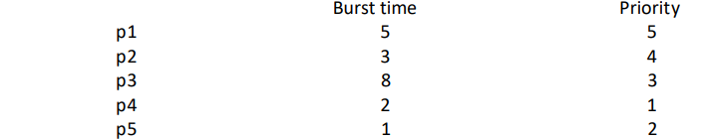

The process has arrived in the order p2, p1, p4, p3 and p5.

14. Given 3 processes A,B and C, three resources x,y and z and following events,

i) A requests x ii) A requests y iii) B requests y iv) B requests z

v) C requests z vi) C requests x vii) C requests y

Assume that requested resources should always be allocated to the request

process if it is available. Draw the resource allocation graph for the sequences.

(6 marks)

b) For the above scenario mention whether it is a deadlock? If it is, how to recover

the deadlock. (4 marks)

15.a) What is demand paging? (2 marks)

b) Consider the reference string 1,2,3,4,2,1,5,6,2,1,2,3,7,6,3,2,1,2,3,6. How many

page faults while using FCFS and LRU using 2 frames? (8 marks)

16. a) Describe the SSTF disk scheduling algorithm (7 marks)

b) List the operations that can be performed on directory . (3 marks)

******************************************************************************************