ST.JOSEPH’S COLLEGE (Autonomous), BENGALURU -27
B.Sc (Biotechnology) – IV SEMESTER
SEMESTER EXAMINATION: APRIL 2023
(Examination conducted in May 2023)
BT422: Molecular Biology
(For current batch students only)
Time: 2 Hours Max Marks: 60
This paper contains TWO printed pages and THREE parts
PART-A
Answer and TEN of the following 2 x 10= 20 marks
- With respect to DNA replication, explain the role of the two divalent cations present in the palm domain of DNA polymerase.
- Briefly explain the function of DnaA with respect to initiation of replication in E. coli.
- Explain the effects of the exposure of DNA to (a) ultraviolet radiation and (b) gamma radiation.
- Explain why telomerase is a ‘ribonucleoprotein.’
- How does termination/finishing of DNA replication differ between E. coli and S. cerevisiae?
- Mention any two characteristics of DNA proposed by Watson and Crick.
- What is abortive initiation?
- How does actinomycin D inhibit transcription?
- How is the mRNA detected by ribosomes in prokaryotes during translation?
- Explain the Wobble hypothesis with an example.
- Draw a diagram illustrating the general structure of operon.
- Briefly explain proximal promoter elements.
PART B
Answer any FOUR of the following: 5x4= 20 marks
- Explain the nucleosome model of DNA compaction.
- What is density gradient centrifugation? Explain how Meselson and Stahl used this technique to provide evidence for semi-conservative model of DNA replication. (1+4)
- Match the enzymes (column A) with the DNA repair mechanisms they are involved in (column B):

Column A |  | Column B
a | MutS | i | Proofreading
b | Photolyase | ii | Base-excision repair
c | Glycolyase | iii | Nucleotide-excision repair
d | UvrA/B | iv | Photoreactivation
e | Artemis | v | Mismatch repair
 |  | vi | Non-homologous end joining
- Study the diagram given below and answer the following questions.
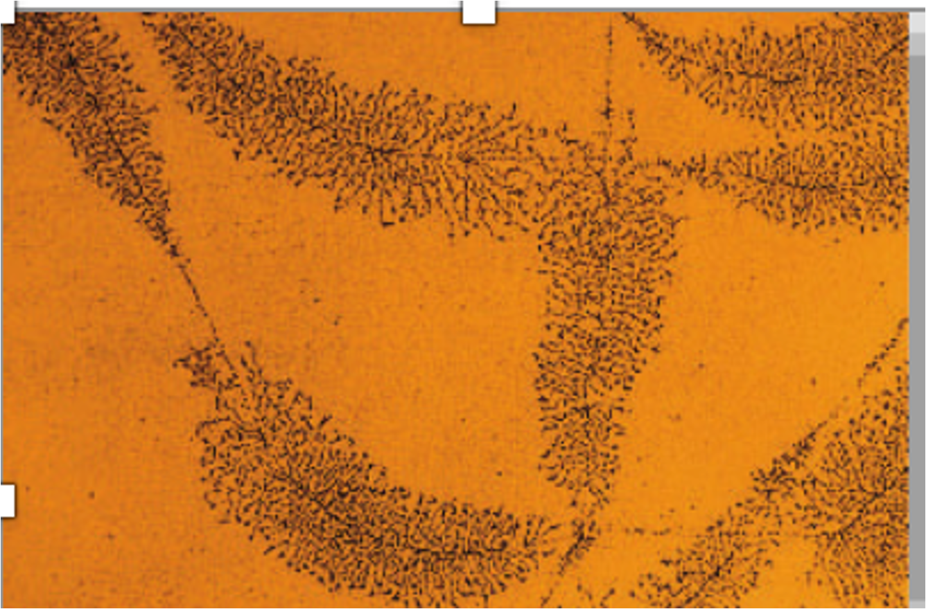
- What does the diagram indicate? (2M)
- What was proved by this experiment? (3M)
- How are tRNAs linked to their corresponding amino acids?
- Can genes be turned on and off in cells? Explain your answer with an example.
PART C
Answer any TWO of the following: 10x 2= 20 marks
- Explain post translational modifications in eukaryotes. (Any five, 5M ). Why are post translational modifications significant? (5M)
- 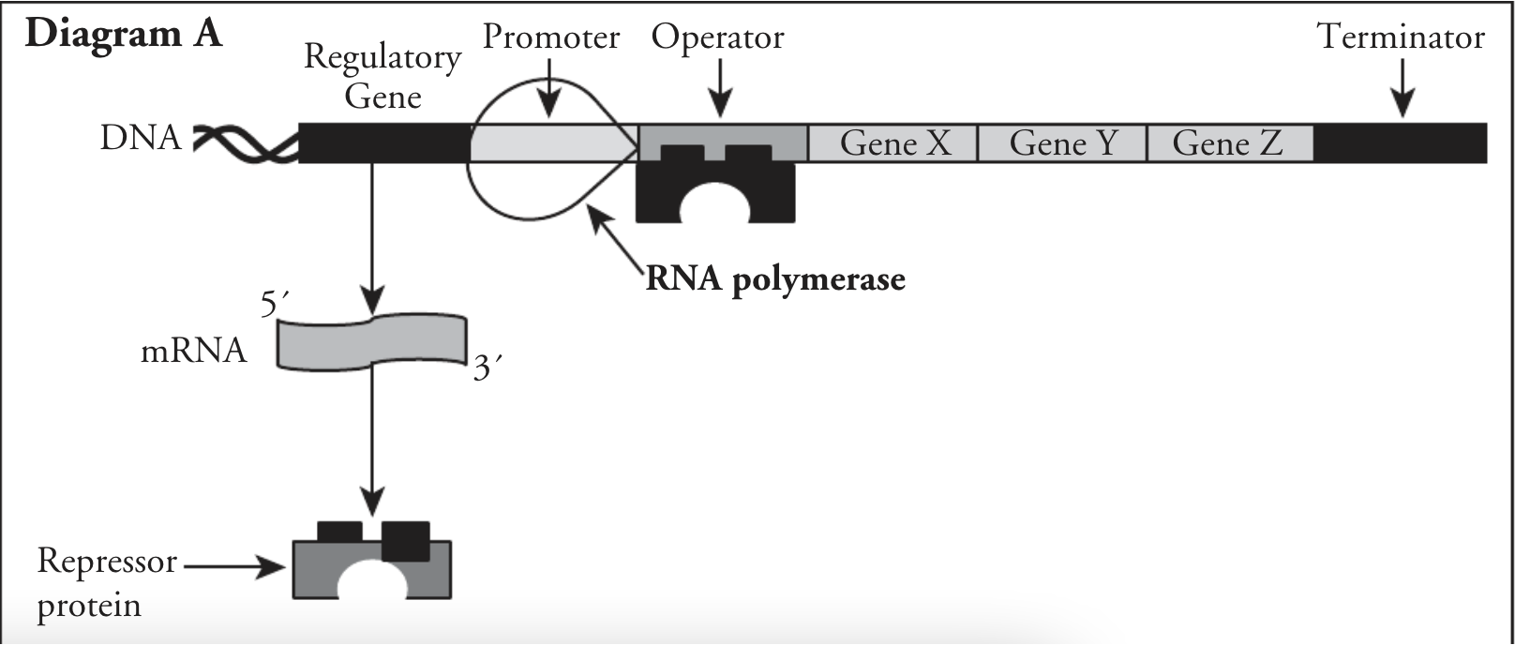
a.What type of operon is illustrated in diagram A (1M)
b.Do you think transcription of gene X , Y and Z takes place according to the diagram? Justify your answer. (1M)
c.Explain what would happen within the lac operon in each of the following scenarios (2M for each):
1)High Lactose
2)Low lactose
3)High Glucose
4)Low Glucose
- a. The DNA polymerase enzyme called Taq, used in in-vitro DNA amplification, does not have 3’ to 5’ exonuclease activity, while another enzyme called Pfu has this activity. Which of the two enzymes will produce DNA of higher sequence accuracy? Explain the reason for your choice. (1+2)
b. Non-homologous end joining (NHEJ) is a DNA repair mechanism. Mention the type of DNA damage which requires NHEJ for repair. Why is this mechanism employed to create mutations through CRISPR technique? (CRISPR: clustered regularly interspaced short palindromic repeats) (1+2)
c. Draw a simple labeled diagram of replication fork. (4 M)

