ST.JOSEPH’S COLLEGE (Autonomous), BENGALURU -27
B.Sc (Biotechnology) – VI SEMESTER
SEMESTER EXAMINATION: APRIL 2023
(Examination conducted in May 2023)
BT6218: Plant, Environmental and Animal Biotechnology
(For current batch students only)
Time: 2.5 Hours Max Marks: 70
This paper contains TWO printed pages and THREE parts
PART-A
Answer and TEN of the following 2 x 10= 20 marks
- A scientist is generating a transgenic tomato variety in which the gene of interest needs to be overexpressed only in fruits. Which type of promoter should be used in this study?
- Differentiate between primary and specialized metabolites with an example for each.
- Why do Bt crops require less pesticide usage?
- How do the raffinose family oligosaccharides (RFOs) help plants overcome stress conditions?
- Name any two cryoprotectants used in the freezing medium.
- What is the function of phenol red in cell culture media?
- What were the most common adverse reactions reported in clinical trials of ATryn?
- What is the mechanism of action of ATryn?
- Define Bioaugmentation and Biostimulation.
- What is e-DNA? Give two examples of bioindicator species.
- Mention any two reasons as to why understanding the environment is important in biotechnology.
- What are biofuels? Give two examples.
PART B
Answer any FIVE of the following: 6x5= 30 marks
- a. Using a flow chart, depict the steps involved in Agrobacterium-mediated transformation of tobacco. (4)
b. Which genes on the Ti plasmid are involved in the formation of crown gall in plant tissues infected by Agrobacterium tumefaciens? (2)
- Why is glyphosate toxic to plants? Explain the mechanism of glyphosate resistance in Roundup-ready crops (2+4)
- Explain the concept of ‘molecular pharming’ taking the example of avidin production in maize.
- What is a knockout mouse? Briefly explain what are the components of the CRISPR system used for generating knockout mice? (3+3)
- What is transient gene expression in mammalian cells? How is it possible to insert the transgene at a specific locus in the genome instead of at a random location? (4+2)
- What are biocontrol agents? Give one example of a biocontrol agent. Explain the advantages and disadvantages of biocontrol agents.
- Draw and explain the overview of various levels of wastewater treatment.
PART C
Answer any TWO of the following: 10x 2= 20 marks
- Given below is the representation of a plant transformation vector. Answer the following questions based on the given vector.
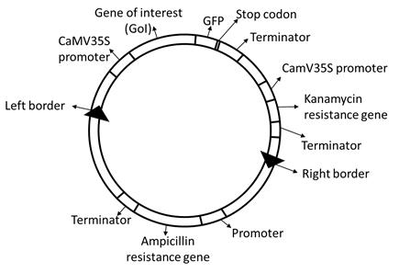
a. What are the ‘left border’ and ‘right border’? Why are they needed in a plant-transformation vector? (2)
b. After a batch of plants are transformed using the given plasmid, how are the transformed plants selected? Justify your choice. (2)
c. Do you think that the transgene expression and protein production in the transformed plant tissues can be visualized under a fluorescence microscope? Why or why not? (3)
d. Identify the selectable marker gene/s and reporter gene/s present in this plasmid (3)
- Describe the strategies used in creating transgenic mice. Explain why it is necessary to create transgenic mice for cancer research. (8+2)
- What are environmental biosensors? Using a diagram, explain the steps involved in designing an environmental biosensor.

