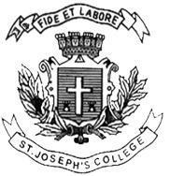
ST. JOSEPH’S COLLEGE (AUTONOMOUS), BENGALURU -27
Registration Number:
Date & Session
Open Elective-IV SEMESTER
SEMESTER EXAMINATION: APRIL 2023
(Examination conducted in May 2023)
VCOE 4 – FILM APPRECIATION

(For current batch students only)
Time: 2 Hours Max Marks: 60
This paper contains ONE printed page and ONE part

Answer any 6 of the following in not more than 180-200 words (10x6=60)

- Explain mise en scene with an example.
- Write a short note on the era of silent films.
- Explain different types of shots.
- Comment on the current trends in OTT.
- Explain any three types of camera movements.
- Explain Chekhov’s Gun with an example.
- Write a short note on the history of Indian cinema.
- Analyze one film of your choice using the concepts you learnt during Film appreciation course.

