Register Number:
Date:

ST. JOSEPH’S UNIVERSITY, BENGALURU-27
MSc COMPUTER SCIENCE -II SEMESTER
END SEMESTER EXAMINATION :APRIL 2023
(Examination Conducted in MAY 2023)
CS8221-MACHINE LEARNING USING PYTHON
(For current batch students only)
Time- 2 hrs |  |  | Max Marks-50
PART A
Answer all of the following (2x5=10)

- Discus the various stages involved in designing a learning system.
- Differentiate between Training data and Testing Data.
- Define entropy.
- Explain the term Gradient Descent.
- Discuss the use of support vectors in SVM.

PART B
Answer any Five of the following (4*5=20)

- Describe feature selection. Differentiate the two methods used for feature selection.
- Explain agglomerative clustering. Compare and contrast the different measures used to calculate the distance between clusters.
- Explain the concept of Bayes theorem with an example
- Explain the algorithm for Back propagation.
- What are hidden Markov models used for? What is the difference between Markov and hidden Markov model?
- Elaborate the following in pandas
- Series (2marks)
- Panel (2 marks)
- Write a python program to implement SVM using scikit package.

PART C

Answer any Two of the following questions (2*10=20)

- a) The values of independent variable x and dependent value y are given below:
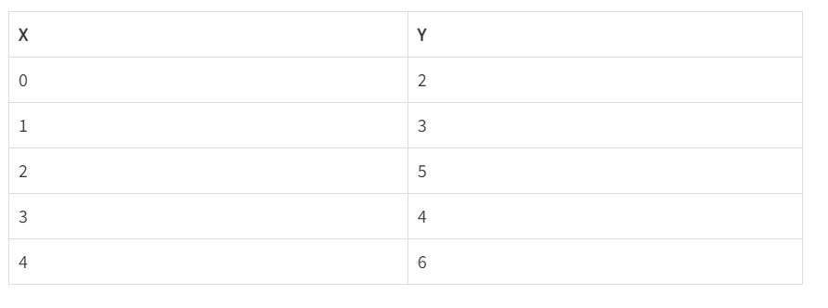Find the least square regression line y=ax+b. Estimate the value of y when x is 10. (7 marks)
b) Identify the major requirements of clustering algorithms. (3 marks)

- a) Explain the concept information gain. (2 marks)

b)For a SunBurn dataset given below, construct a decision tree.
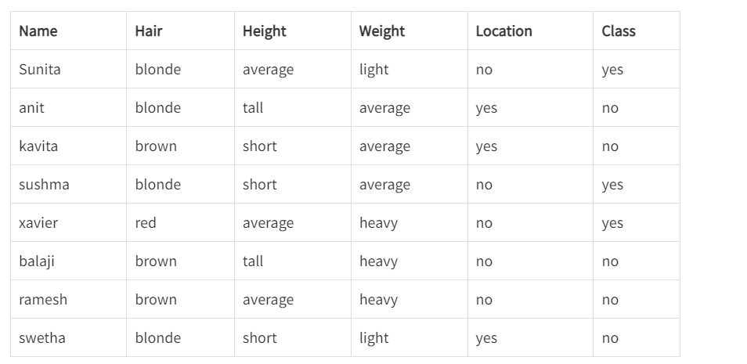
(8 marks)

- a) Discuss the goal of the support vector machine (SVM). How to compute the margin? (6marks)
b) Identify the elements of reinforcement learning. (4 marks)

******************************************************************************************

