ST. JOSEPH’S COLLEGE (AUTONOMOUS), BENGALURU -27
Registration Number:
Date & Session
General English IV SEMESTER
SEMESTER EXAMINATION: APRIL 2023
(Examination conducted in May 2023)
GE 422 – L1 General English

(For current batch students only)
Time: 2 Hours Max Marks: 60
This paper contains three printed pages and two parts

Instructions
- This paper is for the students of PCM, PEM, PMC, MEC, EMS, CMS who opted for the PSA Special Course- Science and the clash of Worldviews
- You’re allowed to use a dictionary during the examination
- You will lose marks for exceeding word limits and lifting from the passage

PART-A

I.A. Read the following passage carefully:
“‘Happy’ is a pretty useless word,” says Dr. Martin Seligman, psychologist and former President of the American Psychological Association. “If you tell someone to be happy, it doesn’t tell [him or her] what to do.”

Seligman compares being happy to falling asleep: it’s not something you can actively do—in the way you can get stronger by lifting more weights. It just kind of has to happen. And as the father of positive psychology—the study what makes a good or meaningful life—much of Seligman’s work has dealt with trying to help people figure how to make it happen.

The species that [was] going through the Ice Ages had been bred, and selected, through pessimism. The mentality that said, "It's a beautiful day in San Diego today, I bet it'll be beautiful tomorrow" got crushed by the ice. What got selected for, in the Ice Ages, was bad weather animals, who were always thinking about the bad stuff that could occur. So what comes naturally to people is pessimism. What needs teaching, because it doesn't come naturally, is optimism.

For reasons tangible and intangible, people have come to associate negativity and hopelessness with a higher degree of intellectual aptitude. How did this come to be? For starters, pessimistic statements — the ones shrouded in doom and gloom — do a better job at grabbing people’s attention than optimistic ones.

Moreover, optimists sound gullible — seemingly unreasonable in clutching on to their hopefulness. Pessimism, however, sounds like advice that is both smart and caring. A corollary to this is also that pessimism is deeply linked to the present and the tangible. People who are cynical are so because they see and hear the realities of our world — which are harsh, morbid, even.
More than half the time, adults are planning futures. And so, the notion that we should live more and more in the moment denies what, evolutionarily, we're really good at. What distinguishes human beings from all of the other animals is that we're creatures of the future. We're not Homo sapiens—”sapiens” is wisdom and knowledge. I'm not impressed by our wisdom and knowledge. But I am impressed [by] how much of our mental life is about the future. I've come to think of us as Homo prospectus. This is what human beings are good at, and it's why we dominate the planet. Not because we live in the moment.

Research suggests that optimism feels good. However, does it always feel good? We suggest that the benefits (and costs) of optimism and pessimism depend on their timing. A study of exam score estimates revealed that, after controlling for actual exam performance, optimistic expectations are unrelated to how people feel immediately before feedback, in contrast to the common wisdom that optimism “feels good.” Furthermore, optimism has costs after feedback—participants who predicted higher scores before feedback felt worse after learning their scores. Finally, people seem to be aware of the potential costs of optimism—participants who predicted higher scores before feedback also anticipated experiencing greater disappointment should they perform poorly. These findings suggest that people may proactively manage their expectations to avoid the costs of optimism.

I.B. Answer the following questions in about 120 words each [3x10=30]
- Do you agree with Seligman’s idea that pessimism comes naturally, while optimism “needs teaching”? Explain why or why not, using another example (such as language or parenting), from the nature versus nurture debates.
- “The benefits (and costs) of optimism and pessimism depend on their timing”. The passage mentions two evolutionary advantages – that pessimism helped our ancestors to survive and that thinking about the future helped our ancestors to survive. Do you see a correlation between these two evolutionary advantages? Provide details based on your reading of the passage.
- As explained in the above passage, pessimism had evolutionary advantages, like helping our ancestors in survival. However, if it isn’t a desirable trait anymore, as explained towards the end of the passage, why do you think it hasn’t gone away yet? Would you consider this as an evolutionary glitch?

I.C. Respond to this question in about 200 words [15 marks]
4. “‘Happy’ is a pretty useless word,” says Dr. Martin Seligman, psychologist and former President of the American Psychological Association. “If you tell someone to be happy, it doesn’t tell [him or her] what to do.” Do you agree that “happy” is a useless word to describe someone’s state of mind? What other word do you think would be more useful? Assuming that optimism “needs teaching”, how would you teach someone to be optimistic? Discuss at least three ways in which this might be possible.

Part- B

II. A. Examine the visual below: The text from the image is reproduced here --- Optimist- half full; Pessimist- half empty; Realist- glass of water; Physicist- gas/liquid; Surrealist; Relativist- half empty/half full; Utopist; Skepticist- it’s not water; Artist
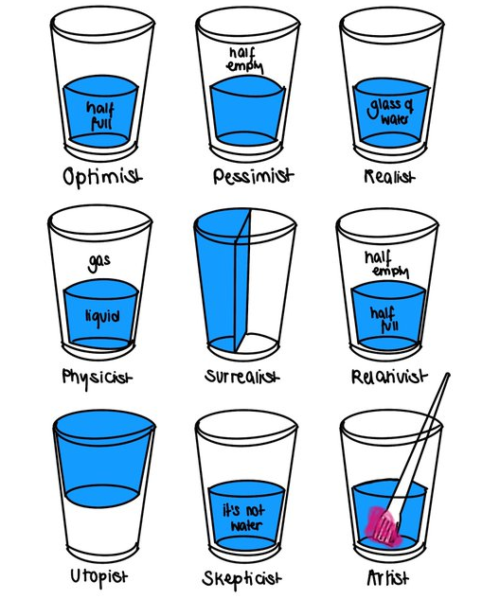

II. B. Answer the following questions in 5-8 sentences: [3x5=15]
- Based on the visual, what do are you able to understand about utopists and surrealists?
- Would you say ‘optimism’ and ‘pessimism’ are worldviews? Corroborate your response based on what you understand about worldviews.
- “To the optimist, the glass is half full, to the pessimist, the glass is half empty, to the engineer, the glass is twice as big as it needs to be”. If you had to add one more perspective to the above visual, which perspective or worldview would you include? Also provide an illustration/drawing or visual representation.

-------------

