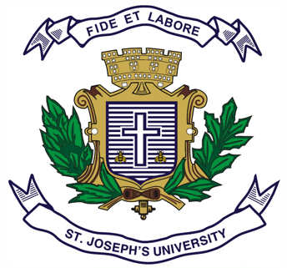

**ST.JOSEPH’S UNIVERSITY, BENGALURU -27**

**B.A. INDUSTRIAL RELATIONS- OPEN ELECTIVE – II SEMESTER**

**SEMESTER EXAMINATION: APRIL 2023**

**(Examination conducted in May 2023)**

**IROE 2: IROE 2 – LABOUR WELFARE IN INDIA**

**(For current batch students only)**

**Time: 2 Hours Max Marks: 60**

**This paper contains TWO printed pages and THREE parts**

**PART-A**

**Answer any TEN questions: (10 x 2= 20 marks)**

1. Define Industrial Relations.
2. What is an Occupational Hazard?
3. Define Job Stress.
4. List any two Occupational Diseases.
5. Expand I.L.O. When was it Established?
6. Define Quality of Work Life.
7. What is the meaning of “Industry”?
8. Define labour Welfare.
9. Name any two Indian Freedom Fighters who have also worked for Labour Welfare in India.
10. Who is the Present Labour Minister of India?
11. What is Industrial Health?
12. Who coined the term Industrial Relations?

**PART-B**

**Answer any FIVE questions: (5 x 5 =25 marks)**

1. What are the Advantages of Labour Welfare in India?
2. Why is Industrial Relations considered a Multi-Disciplinary Subject? Justify.
3. Write a short note on the problems faced by health workers during COVID 19 pandemic (2020-2021) period.
4. What are the various Strategies to improve QWL?
5. Write short notes on ILO.
6. What are the Statutory Labour Welfare measures in India as per The Factories Act, 1948?
7. What role do HR managers play in counselling?

**PART-C**

**Answer any ONE question: (15 x 1 =15 marks)**

1. Write an essay on various Occupational Hazards and its effects on labour in India.
2. Write an essay on the negative effects of Job stress and various measures to tackle Job Stress.