**ST. JOSEPH’S UNIVERSITY, BENGALURU -27**

**M.Sc (ZOOLOGY) – II SEMESTER**

**SEMESTER EXAMINATION: APRIL 2023**

**(Examination conducted in May 2023)**

**ZO 8122 – BIOLOGY AND DIVERSITY OF CHORDATES**

**(For current batch students only)**

**Time: 2 Hours Max Marks: 50**

**This paper contains TWO printed pages and FOUR parts**

**PART-A**

**Answer the following questions (5x1=5)**

1. Why are hemichordates classified as separate phylum from chordata?
2. List two functions of the tunic.
3. Contraction of which muscle helps in opening the mouth of snakes by depressing the lower jaw?
4. Why birds are considered as glorified reptiles?
5. What are the different types of dentition according to the mode of attachment of teeth in mammals?

**PART-B**

**Answer the following questions (5x2=10)**

1. Comment on the image below

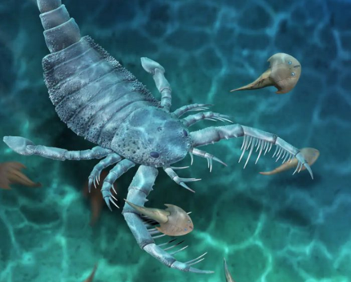

1. Mention the role of a. Wheel organ b. Jacobson’s organs
2. Identify the given type of palate and comment on it

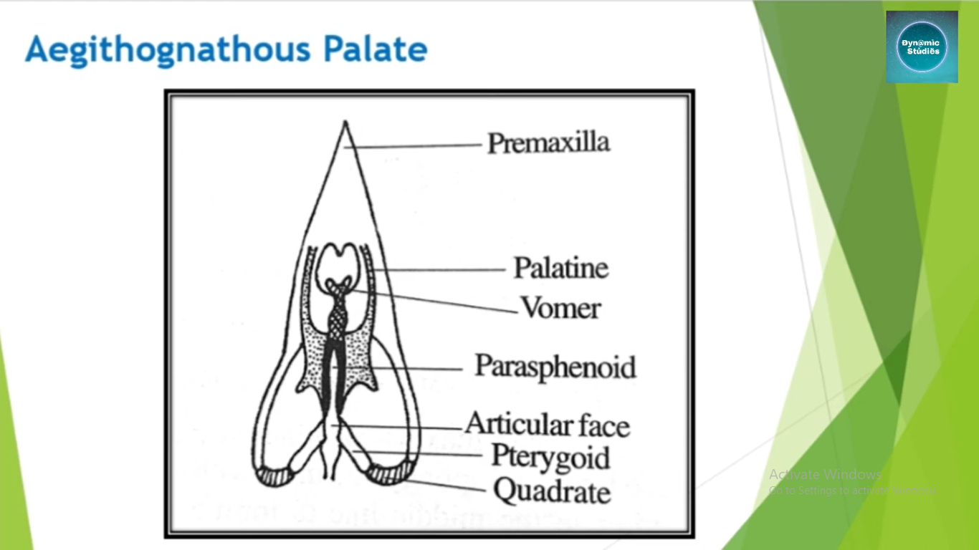

1. List out different types of fangs in snakes with examples.
2. Differentiate between prototherian and metatherian mammals.

**PART-C**

**Answer any THREE of the following questions (3x5=15)**

1. Trace the evolutionary changes between mesonephros and metanephros.
2. Explain the salient features of origin of amphibia.
3. Briefly describe the biting mechanism in snakes with a neat diagram.
4. Write a short note on the evolution of mammals.

**PART-D**

**Answer any TWO of the following questions (2x10=20)**

1. With sketches explain the types of jaw suspensorium in vertebrates.
2. Explain the types of swim bladders and accessory respiratory structures in fishes.
3. Discuss how the integuments of reptiles and birds are adapted to their respective modes of life.