

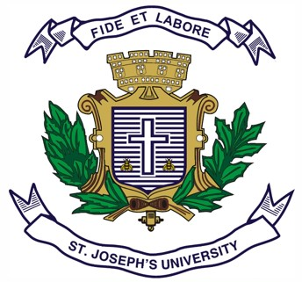**ST. JOSEPH’S UNIVERSITY, BENGALURU -27**

**MCOM – III SEMESTER**

**SEMESTER EXAMINATION: OCTOBER 2023**

**(Examination conducted in November /December 2023)**

**MCO9220: Business Ethics and Corporate Governance**

**(For current batch students only)**

**Time: 2 Hours Max Marks: 50**

**This paper contains 1 printed page and 3 parts**

**PART- A**

**Answer any TWO of the following questions: (2 x 5 = 10)**

1. Briefly explain the theory of consequentialism.
2. List the benefits of good corporate governance.
3. Write a short note on the importance of ethical marketing.

**PART- B**

**Answer any TWO of the following questions: (2 x 15 = 30)**

1. Explain the various ways of corporate crimes in companies.
2. a) What are the ethical and social issues in advertising? (7 marks)
3. What are the deceptive practices in marketing? (8 marks)
4. Explore how the companies conduct CSR activities.

**PART- C**

**Answer the following compulsory question: (1 x 10 = 10)**

1. Explain about the following committees:
   1. Birla Committee (5 marks)
   2. Narayana Murthy committee (5 marks)