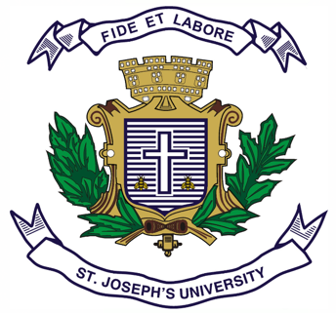
Registration Number:
Date & session:
ST. JOSEPH’S UNIVERSITY, BENGALURU -27
MA ADVERTISING AND PUBLIC RELATIONS – I SEMESTER
SEMESTER EXAMINATION: OCTOBER 2023
(Examination conducted in November /December 2023)
APR 7622 – POLITICAL PUBLIC RELATIONS & ADVERTISING
(For current batch students only)

Time: 2 Hours Max Marks: 50

This paper contains ONE printed page and TWO parts

- Write short notes on any FIVE in 150 - 200 words each. (5X6=30)
  - Media Logic vs. Political logic
  - Pseudo-event with examples
  - Lobbying
  - Americanisation of politics
  - Chain and Conglomerate Media ownership
  - Public diplomacy and its approaches
  - Corporate Foreign Policy

- Answer any TWO of the following in 300 words each. (2X10=20)
- Who are spin doctors? What strategies and techniques do they employ in shaping public perception of political candidates or issues?
- How are images, myths, and symbols used in political PR and advertising to convey messages and build narratives?
- What is propaganda? How does it influence public perception and opinions?
- What is political campaigning? Explain the key components of a political campaign, and how do they contribute to the electoral process?
************

