**ST JOSEPH’S UNIVERSITY, BENGALURU - 27**

Registration Number:

Date & Session:

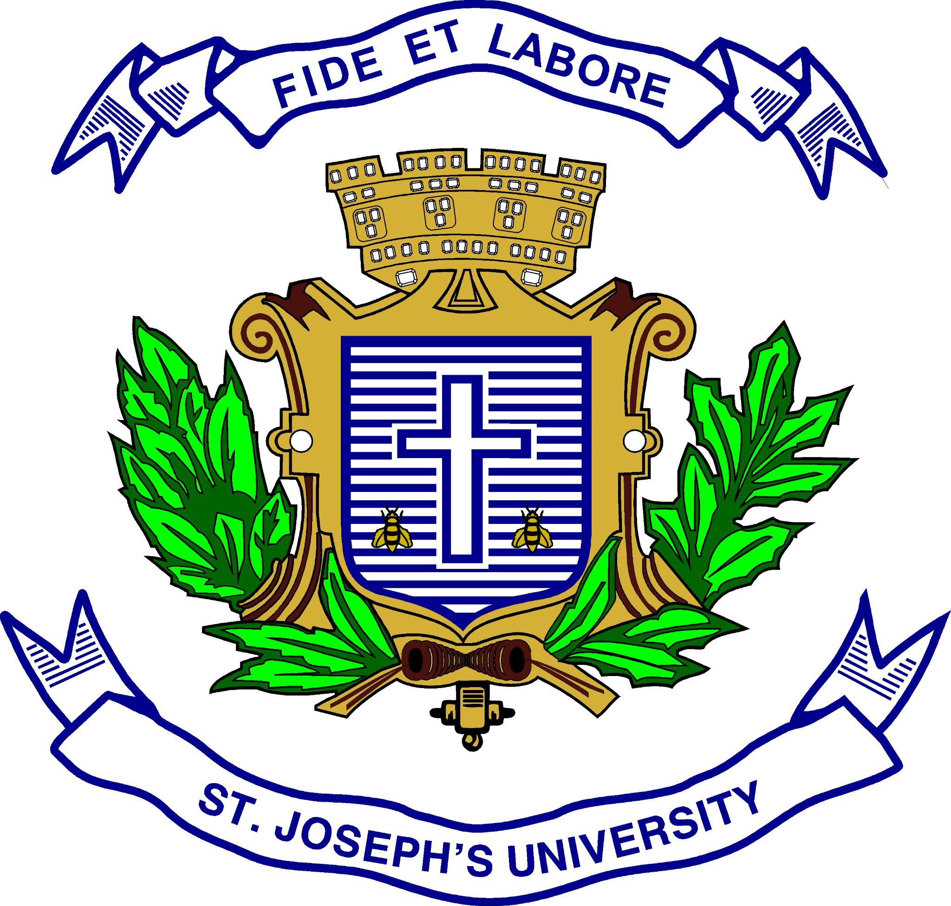**M.Sc. ENVIRONMENTAL SCIENCE AND SUSTAINABILITY– III SEMESTER**

**SEMESTER EXAMINATION: OCTOBER 2023**

**(Examination conducted in November /December 2023)**

**ES 9323: ENVIRONMENT, SOCIAL AND GOVERNANCE**

**(For current batch students only)**

**Time: 2 Hours Max Marks: 50**

**This paper contains TWO printed pages and THREE parts**

***Instruction: Draw diagrams wherever necessary***

**PART – A**

**Answer any FIVE of the following 2m X 5q = 10m**

1. What is CER frame work?
2. Give two examples of ESG products.
3. Who is a stakeholder? Give an example.
4. List two reasons for the growing interest in ESG disclosures.
5. State the meaning of assurance.
6. What are KPIs?
7. In what way can a business contribute to sustainable development?

**PART – B**

**Write explanatory notes on any FOUR of the following 5m X 4q = 20m**

1. Social Return on Investment
2. Evolution of BRSR
3. Integrated reporting
4. Triple Bottom Line
5. TCFD
6. Any two corporate governance metrics.

**PART – C**

**Answer ALL the following 10m X 2q = 20m**

1. In 2021, humans consumed [1.7](https://www.genevaenvironmentnetwork.org/resources/updates/earth-overshoot-day-2021/) times more resources than Earth generates annually because our economic outlook is based on production, use and disposal. Such an economy is not sustainable and that is the reason why the [concept of circular economy](https://research.aimultiple.com/circular-economy/) (CE) is trending nowadays. The most basic principles of CE is to use trash as a raw material for production through innovation, recycling, or repairing and reusing existing products.

H&M’s “Let’s Close the Gap” project began in [2013](https://www2.hm.com/en_gb/sustainability-at-hm/our-work/close-the-loop.html) as a [CE best practice](https://research.aimultiple.com/circular-economy-best-practices/) that collects and categorizes discarded clothing from customers. If the garment is in decent condition, they will restore it and find a new owner for it. If a garment reaches the end of its useful life, H&M will recycle it and reuse the material in new goods. Customers who bring in their old clothes are rewarded with tokens that can be used to get a discount at H&M shops. Incentivizing customers creates a complete CE loop. In 2019, [57%](https://www.forbes.com/sites/markfaithfull/2020/10/13/hm-and-ikea-want-your-old-stuff-back-heres-why/?sh=2ea326f20986) of H&M’s raw materials were sustainable, according to Forbes. By 2030, the company hopes to improve it 100 percent.

Apart from this, H&M has a human rights policy in place. The company strictly prohibits any form of forced labour and modern-day slavery. The company promotes gender equality in their supply chain through equal wages, health and safety and representation. H&M website states that, “Everyone should have access to decent, meaningful jobs with fair compensation and benefits, in safe and secure workplaces that are free from discrimination and with the right to freedom of association.”

H&M also believes in engaging with communities. When war broke out in Ukraine, H&M donated EUR 750,000 each to UNICEF and UNHCR. They gave over 150,000 garments to UNHCR and their customers donated almost SEK 11 M. During the pandemic, the company opened up their social channels to aid organisations like the Red Cross and World Health Organisation (WHO) to communicate health and safety messages.

What is Circuar economy? Explain with respect to H&M clothing.

**OR**

Explain the benefits that H&M could stand to gain through the “Let’s Close the Gap” project and their employee policies.

1. Explain the various social ESG metrics and relate the same to H&M’s policy on the same.

**OR**

Explain in detail any 5 ESG related practices of a company of your choosing and detail why this company is an example of sustainability leadership.