ST. JOSEPH’S UNIVERSITY, BENGALURU -27
Registration Number:
Date & session:
M. Sc., (ZOOLOGY) – I SEMESTER
SEMESTER EXAMINATION - OCTOBER 2023
(Examination conducted in November /December 2023)
ZO 7522 – ANIMAL BEHAVIOUR
Time: 2 Hours Max Marks: 50
This paper contains TWO printed pages and FOUR parts
Answers in point form are acceptable.
PART-A
Answer ALL of the following: 5 x 1 = 5
- Sticklebacks suddenly digging in the vertical position during a boundary clash is an example for ………………
a) Negative photo taxis b) Positive photo taxis
c) Displacement activity d) None of the above
- ………… trophallaxis is related to the exchange of food among the members through mouth to mouth.
a) Stomodeal trophallaxis b) Proctodeal trophallaxis c) Both of the above d) None of the above
- Cooperation among animals usually involves some form of Altruism. (True/False)
- In group foraging, what does ‘Many eyes hypothesis’ refer to?
- Ivan Pavlov: Dog: B. F. Skinner: ……….
PART B
Answer any FIVE of the following 5 x 2 = 10
- Enlist the types of migration in birds.

- Comment on Leks
- Label the diagram and comment on their role in controlling the behaviour.
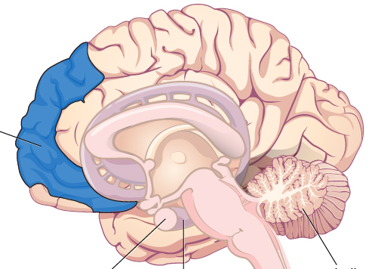
- Identify the kind of behaviour the image represents and comment on it.
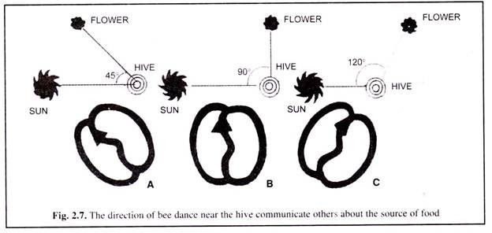
- Distinguish between hibernation and aestivation
PART C
Answer any THREE of the following 3 x 5 = 15
- Briefly discuss the significance of animal behaviour.
- Write notes on circadian and circannual rhythms with examples.
- Discuss the types of primate societies
- Comment upon the type of navigation associated with the image given below (with example).
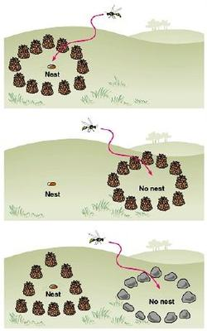
- How do animals communicate using visual signals? Discuss their advantages and disadvantages.
PART D
Answer any TWO of the following 2 x 10 = 20
- Explain the contribution of Karl Von Frisch in animal communication.
- Elaborate on eusociality in honey bees and add a note on Hamilton’s rule.
- Discuss the how, when and where in relation to migration in Fishes.

