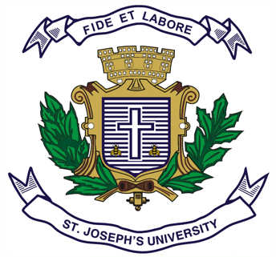
Registration Number:
Date & session:

ST JOSEPH’S UNIVERSITY, BENGALURU -27
MA (ENGLISH) – I SEMESTER
SEMESTER EXAMINATION: OCTOBER 2023
(Examination conducted in November /December 2023)
EN 7418: WORLD LITERATURES
(For current batch students only)

Time: 2 Hours Max Marks: 50
This paper contains 1 printed page and 4 parts

PART A
Answer ANY ONE of the following questions (200-250 words). (1x15=15)

- How is the theme of alienation being explored in Kafka’s The Metamorphosis.

- “Born in Nobility” is one essential quality Aristotle refers to with respect to an ideal hero. Discuss how this notion has changed with reference to the European literature you have studied in this semester.
PART B
Answer the following questions (200 words). (2X10=20)

‘One Eyed Monster’
“So, you ask me the name I’m known by, Cyclops?
I will tell you. But you must give me a guest-gift
as you’ve promised. Nobody — that’s my name. Nobody
so my mother and father call me, all my friends.’’

- Elucidate and the dichotomy between the wit and hamartia with reference to the above lines and book 9 of Odyssey

- Discuss how Anna’s pursuit of her own desires clash with the societal expectations of a woman during the times.

PART C
Answer ANY ONE of the following questions (150-200 words). (1x5=5)

- In what ways does Montaigne argue that vanity is a universal human trait?

- I prefer talking to doctors about something else.
I prefer the old fine-lined illustrations
I prefer the absurdity of writing poems
to the absurdity of not writing poems.
I prefer, where love’s concerned, nonspecific anniversaries
that can be celebrated every day.

How would you relate the speaker's preferences to the title of the poem Possibilities by Wislawa Szymborska?
PART D

Answer the following question (200-250 words). (1x10=10)
- “Tragedy is an imitation of the action that is serious, complete and of a certain magnitude” – Aristotle.
Present your understanding of how this idea tragedy has evolved through the Self-Study text(s) from your syllabus.

