

**ST. JOSEPH’S UNIVERSITY, BANGALORE – 27**

**B.A Communicative English — I SEMESTER**

**SEMESTER EXAMINATION: OCTOBER 2023**

**(Examination conducted in November/December 2023)**

**CE 121 — COMMUNICATIVE ENGLISH I**

**(For current batch students only)**

**Time: 2 Hours Max Marks: 60**

**Instructions:**

1. This paper contains FOUR printed pages and FOUR parts.
2. Please provide word counts for all your answers.

**PART A**

**Below is a selection from *The Cost of Living* by Deborah Levy. Read the passage carefully and answer the questions that follow.**

As Orson Welles told us, if we want a happy ending, it depends on where we stop the story. One January night I was eating coconut rice and fish in a bar on Colombia’s Caribbean coast. A tanned, tattooed American man sat at the table next to me. He was in his late 40s, big muscled arms, his silver hair pinned into a bun. He was talking to a young English woman, perhaps 19 years old, who had been sitting on her own reading a book, but after some ambivalence had taken up his invitation to join him. At first he did all the talking. After a while she interrupted him.

Her conversation was interesting, intense and strange. She was telling him about scuba diving in Mexico, how she had been underwater for 20 minutes and then surfaced to find there was a storm. The sea had become a whirlpool and she had been anxious about making it back to the boat. Although her story was about surfacing from a dive to discover the weather had changed, it was also about some sort of undisclosed hurt. She gave him a few clues about that (there was someone on the boat who she thought should have come to save her) and then she glanced at him to check if he knew that she was talking about the storm in a disguised way.

He said, “You talk a lot don’t you?”

It was not that easy to convey to him, a man much older than she was, that the world was her world, too. He had taken a risk when he invited her to join him at his table. After all, she came with a whole life and libido of her own. It had not occurred to him that she might not consider herself to be the minor character and him the major character. In this sense, she had unsettled a boundary, collapsed a social hierarchy, broken with the usual rituals. She could have stopped the story by describing the wonder of all she had seen in the deep calm sea before the storm. That would have been a happy ending, but she did not stop there. She was asking him (and herself) a question: do you think I was abandoned by that person on the boat?

1. **Answer ANY THREE of the following questions in 5-6 sentences. (3x5=15)**
2. The writer describes the American man as tanned and tattooed. She also writes that “he was in his late 40s, big muscled arms, his silver hair pinned into a bun.” But we get very little description about the young English woman. Describe how you see this young woman in one paragraph – based on what you imagined of her while reading.
3. If you narrated a story and the listener responded with “You talk a lot, don’t you?”, how would you react?
4. Is there someone in whose company you feel like a minor character? Recall a situation in which you felt like the minor character.
5. Consider just the first paragraph of the above passage. Write a paragraph to follow this one that would work as a happy ending.

**PART B**

1. **Answer the following question in 100-150 words. (15 marks)**
2. Following are eight phrases in the imaginary language Kliptoon, transcribed into the Latin alphabet. Study the phrases carefully and figure out the Kliptoon phrase for WHITE CAR. Explain how you arrived at your answer. How useful are the ideas of langue and parole in explaining your answer?

*tikipran* red car *dankaal* two shoes

*levakaal* white shoes *yayakrim* yellow butterfly

*tikitrin*  red eyes *neelpran* one car

*yayaples* yellow horn *levabil* white boy

**PART C**

1. **Answer the following question in 100-150 words. (2x10=20)**

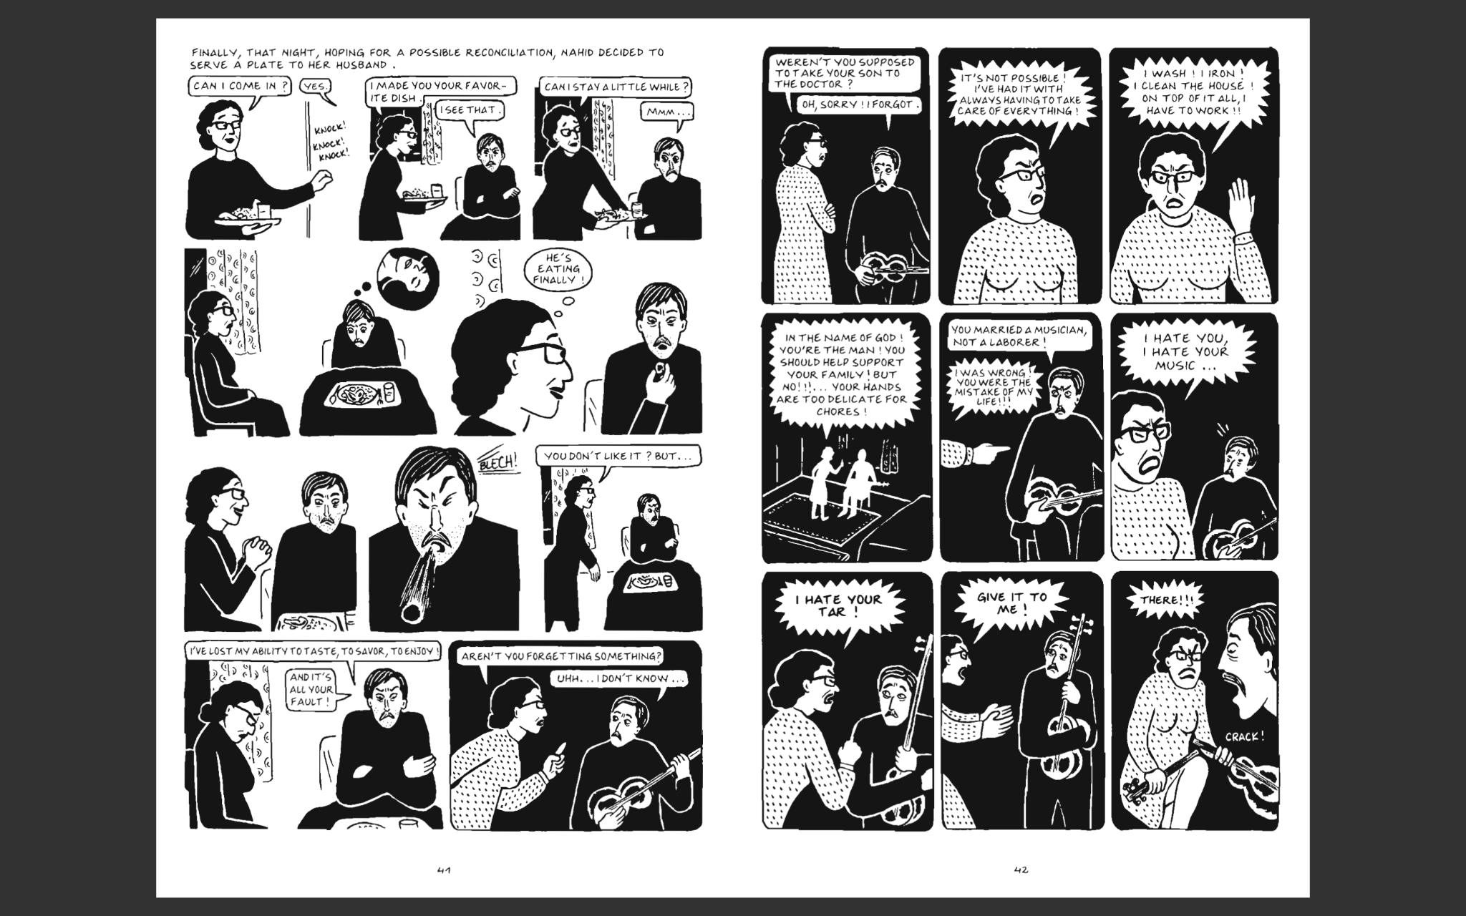

1. Above is a panel from *Chicken with Plums* by Marjane Satrapi. Why do you think one speech bubble is jagged while the other is smooth?
2. **Read the following news article from Deccan Herald and answer the question below.**

A parody song in Kannada, about a girl moving from a small town to Bengaluru and adapting to a new life, is going viral. ‘Naanu Nandini’ has clocked more than 25 million views in 10 days. The parody is based on Danish pop band Aqua’s peppy ‘Barbie Girl’ tune and is set to simple words in Kannada, so the makers had a hunch it would do slightly better than the content they usually create.

“We were expecting 2-3 million views. But this has blown up. About 15,000 accounts have made reels on our parody,” says content creator, comedian and protagonist of the song, Vicky Pedia aka Vikas Sangam. His personal favourites feature a group of girls dancing to ‘Naanu Nandini’ at a playground in Bengaluru, a young sister-brother duo from Dubai singing in their sweet voice, and a Kannadiga living in South Korea, who goes from looking sad to “all pumped up” the moment the track kicks in.

Vikas feels ‘Naanu Nandini’ has caught on because people can relate to their own experiences of moving to Bengaluru. “About 90 per cent of the parody is my life’s story. I shifted to Bengaluru from Chitradurga to study engineering,” he shares. He describes the subsequent days in the parody as PG-li irtini; IT kelsa maadtini; Oota sari illa andrunu tintini; bandid duddella, maneg kalistini (I live in a PG accommodation; I work in an IT company; Food is bad but I still eat it; Whatever I earn, I send it home).

**Compose a headline for this news story. Your headline must not be more than EIGHT WORDS and must include the word Nandini. Add a short note of 100-150 words explaining your choice.**

**PART D**

1. **Respond to ANY ONE of the following prompts in 100-150 words. (10 marks)**
2. Animals with attitude
3. Answering attendance

*****