Registration Number:
Date & Session

ST JOSEPH’S UNIVERSITY, BENGALURU -27
III SEMESTER BA/BSC/BCOM/BCA/BVC/BSW
SEMESTER EXAMINATION: OCTOBER 2023
(Examination conducted in November / December 2023)
GE 322 – SPECIAL COURSE: READING NATURE

(For current batch students only)
Time: 2 Hours Max Marks: 60
This paper contains THREE printed pages and THREE parts

PART-A

- Read the poem given below by Mary Oliver titled “How it Begins”:

A puppy is a puppy is a puppy.
He’s probably in a basket with a
bunch
of other puppies.
Then he’s a little older and he’s
nothing
but a bundle of longing.
He doesn’t even understand it.

Then someone picks him up and
says,
“I want this one.”

- Answer ALL of the following questions in 5 – 8 lines each. (3x5=15)

- What do you think the “it” in the title of the poem refers to?
- The poet describes the puppy as “a bundle of longing”. What do you understand from this description?
- Does the first line of the poem strike you as odd? Why? What do you think the line means?

PART-B

B. Look at the following edited piece of art by pet_foolery:

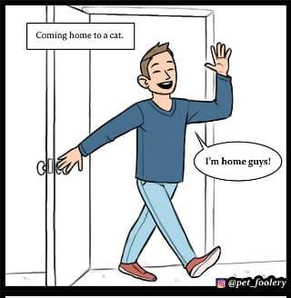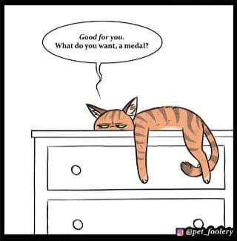

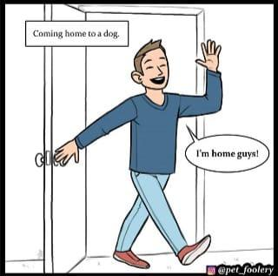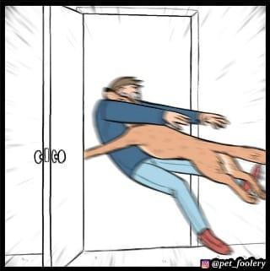
(The text in the panels read:
Coming home to a cat.
The Cat: Good for you. What do you want, a medal?
The man: I’m home guys!
Coming home to a dog.
The man: I’m home guys!)

I.B. Answer ANY THREE of the following questions in 100 – 150 words each.
(3x10=30)
- What differences do you notice in the reactions of the cat and dog in seeing the human? Do you agree with the artist’s portrayal of cats and dogs?
- Do you think that keeping animals as pets is an act of cruelty? Why/why not?
- The man is not shown only in the second panel. Why do you think this is the case?
- If you could have any animal as a pet, which animal would it be? Why?

PART-C

- Read the following comic strip by Dami Lee.

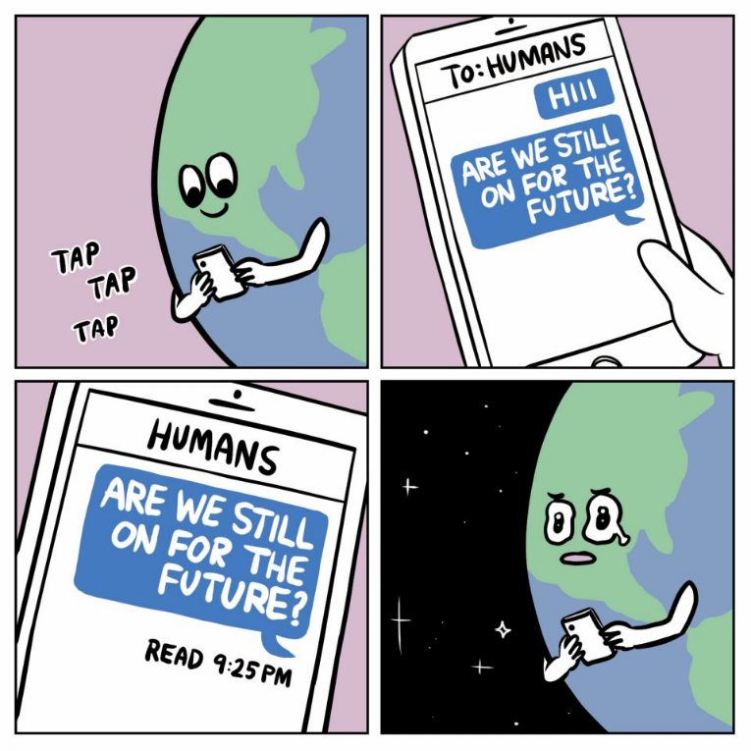
(The text in the panels read:
Tap Tap Tap
To: Humans
Hii
Are we still on for the future?
Humans
Are we still on for the future?
Read 9:25 PM)

I.C. Answer ANY ONE of the questions below. (15 marks)

- Why do you think Dami Lee uses the complexities of texting to talk about the
extinction of humans? Do you find the read notification ironic? Why?

- In many depictions of the future, the world is portrayed as ending because of human greed and our exploitation of nature. Do you think that human greed will ultimately destroy Earth in the not-too-far future? Argue your stance.

