ST JOSEPH’S UNIVERSITY, BENGALURU -27
Registration Number:
Date & session:
MA JOURNALISM AND MASS COMMUNICATION – III SEMESTER
SEMESTER EXAMINATION: OCTOBER 2023
(Examination conducted in November /December 2023)
MC 9323 – DATA JOURNALISM
(For current batch students only)

Time: 2 Hours Max Marks: 50

This paper contains TWO printed pages and TWO parts.

PART A
Answer any FIVE of the following questions in 200 words each. (5X6=30)
- Discuss Adrian Holovaty’s blog post “A fundamental way the newspaper sites need to change”.
- Write a note on precision journalism.
- Define web scraping. List four of the major challenges in web scraping.
- Refer to Microsoft Excel or Google Sheets, and explain the significance of pivot tables with a relevant example.
- Explain a few types of visualisations used in data storytelling.
- Elucidate the phenomenon of fake news in the era of data journalism.
- Describe the Right to Information (RTI) Act as a tool to gather information in journalism.
PART B
Answer any TWO of the following questions in 300–350 words each. (2X10=20)
- “Most of the flaws with data”, according to the American Press Institute, “are the same as with human sources: Error, bias, unreliability, and misunderstandings.” In this context, explain the ethical concerns and challenges of data journalism.
- Mention a data journalism tool/program of your choice and describe its strengths and weaknesses.
- Write a news report based on this following graph representing the conviction rate for crimes against women published by The Hindu: 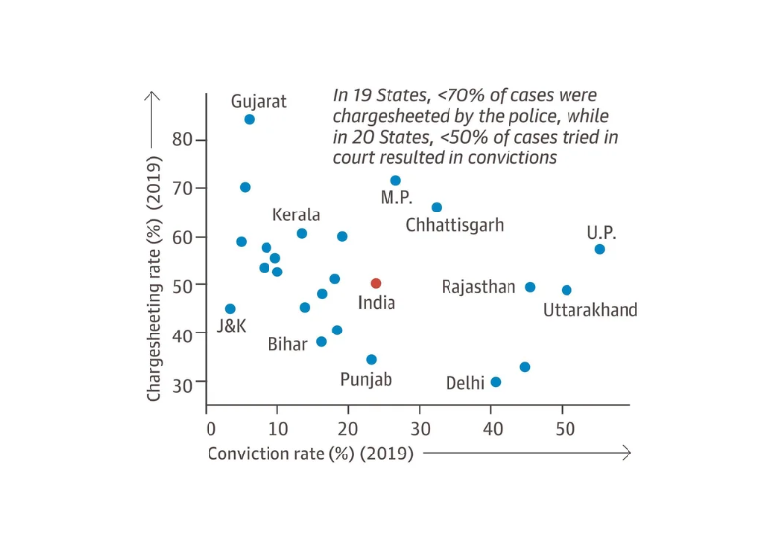
- With reference to two recent examples of data-driven stories in a news publication, discuss the significance of data journalism in the Indian context.

***********

