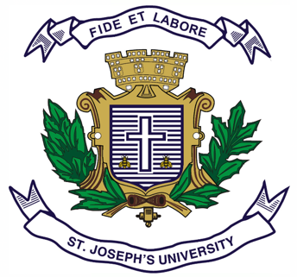
ST.JOSEPH’S UNIVERSITY, BENGALURU-27
Registration Number:
Date & session:
B.A. (HISTORY) – I SEMESTER
SEMESTER EXAMINATION: OCTOBER 2023
(Examination conducted in November/December 2023)

I Semester – OPEN ELECTIVE
HSOE 1: TOURISM IN KARNATAKA
(For current batch students only)
Time: 2 Hours Max Marks: 60
This question paper has 1 printed page and 2 parts

SECTION - A
Answer any 10 of the following (2 x 10 = 20)
1. Trace the etymology of the term ‘Karnataka.’
2. Describe the uniqueness of Karaga festival.
3. What was grand tour?
4. Which famous sites in Karnataka were given world heritage status by UNESCO in
September 2023?
5. Give the details of a famous bird sanctuary in Karnataka.
6. What do you know about Bidariwares?
7. Write about the famous sweets of North Karnataka.
8. Who introduced sericulture in Karnataka? What is its significance in the state?
9. Write about Kadalekai parishe.
10. What is pith work? What is its importance in Karnataka?
11. Mention any two socio-cultural impacts of tourism.
12. Write about the sandalwood carving industry in Karnataka.
SECTION - b
Answer any FOUR of the following questions (10 x 4 = 40)
13. What are the vital components of tourism? Discuss by looking at the role of KSTDC in
promoting tourism in Karnataka.
14. Several motivating factors have contributed to the growth of various kinds of tourism.
Explain those different types.
15. What is culinary tourism? Describing its significance, talk about the various culinary zones
of Karnataka.
16. Highlight the historical significance of Hampi and Pattadakkal in the tourism map of
Karnataka.
17. Do you think fairs are important in cultural tourism? Elucidate in the context of Karnataka.
18. How is beach and adventure tourism relevant in Karnataka?
*****************

