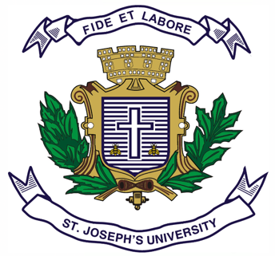
ST.JOSEPH’S UNIVERSITY, BENGALURU -27
Registration Number:
Date & session:
B.A. INTERNATIONAL RELATIONS AND PEACE STUDIES - III SEMESTER
END SEMESTER EXAMINATION: OCTOBER 2023
(To be conducted in December 2023)
IINP 3122:Global Political Thought

Time: 2 Hours Max Marks: 60

This paper contains one printed page and three parts

Part A
Answer any FIVE of the following questions in about 40-50 words each (3x5=15)

- What are the traits of a new prince, according to Machiavelli?
- What is the concept of “harm principle” by J S Mill?
- What were the divisions in society highlighted by Karl Marx?
- What was Mao’s approach to International Relations?
- What are some of Mahatma Gandhi's views on nonviolence?
- Name two BR Ambedkar’s proposed solutions for the eradication of caste system?
- What were the key principles of Jawaharlal Nehru's political thought?

Part B
Answer any THREE of the following questions in about 100-150 words each (5x3=15)

8. What is Machiavelli's concept of political power and its relationship with morality?
9. What is the legacy of Marx's political thought?
10. What is Rawls’ theory of justice?
11. Discuss Ambedkar's perspective on women's rights and gender equality.
12. What was Nehru’s approach foreign policy and international relations?

Part C
Answer any TWO of the following questions in about 200-250 words each (15x2=30)

13. What has been J S Mill's stance on utilitarianism?
14. What is Marx's theory of historical/dialectic materialism?
15. What is Ann Tickner's concept of "difference feminism”?
16. How did the ideologies of Mahatma Gandhi contribute to the success of the Independence movement of India?

