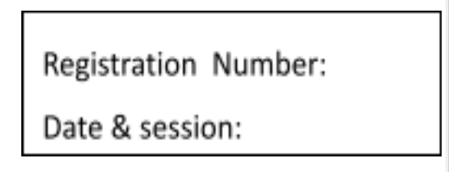

ST. JOSEPH’S UNIVERSITY, BENGALURU-27
B.A. PSYCHOLOGY – I SEMESTER
SEMESTER EXAMINATION: NOVEMBER 2023
(Examination conducted in November/ December 2023)
PY 121– FOUNDATIONS OF PSYCHOLOGY
(For current batch students only)

Time- 2 Hours Max Marks-60

This paper contains TWO printed pages and THREE parts

Part A
Answer all the following questions (10 x 2=20)

    - Mention any two characteristics of observational method.
    - Name the divisions of nervous system.
    - Describe spontaneous recovery with an example.
    - You step into a bakery and immediately get overwhelmed with the sweet smell of freshly baked donuts. However, by the time you are done billing, you hardly notice the smell any longer. This is due to which phenomena?
      - Systematic desensitization
      - Diffusion
      - Sensory adaptation
      - Selective attention.
    - Provide an example each for flashbulb memory and autobiographical memory.
    - Name any two neurotransmitters.
    - Describe attention span with an example.
    - Imagine that you have finally decided to go dispose-off the garbage at home on time in order to avoid the constant nagging from your parents- that you are irresponsible and lazy. What kind of reinforcement is in play here, to make you do the act?
      - Positive Punishment
      - Variable Schedule Reinforcement
      - Counter Conditioning
      - Negative Reinforcement
    - Name the three processes involved in memory?
    - In which of the following study methods, do we focus on in-depth study of one person, group, or event where nearly every aspect of the subject's life and history is analyzed to seek patterns and causes of behavior?
      - Clinical Study
      - Observational Study
      - Case Study

Longitudinal Study

Part B

Answer any FOUR of the following questions (4 x 5 =20)

    - Explain the schedules of reinforcement with suitable examples.
    - Differentiate between sympathetic and parasympathetic nervous system with suitable examples.
    - List out the characteristics of any three defense mechanisms with appropriate examples.
    - Write a short note on the causes of forgetting.
    - Describe the concept of shaping and chaining with suitable examples.
    - Outline the determinants of attention with suitable examples.

Part C
Answer any TWO of the following (2 x 10=20)

    - Explain Baddley’s working memory model with suitable examples.
    - Elaborate on depth perception with examples.
    - Enumerate on the theory of classical conditioning and its underlying principles.
    - Differentiate between the structuralism and functionalism with examples. Point out their significance in the development of various other schools of thought.

