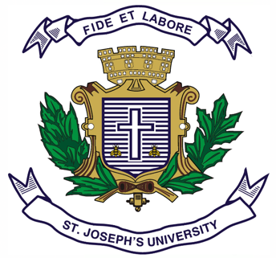
ST.JOSEPH’S COLLEGE (Autonomous),, BENGALURU -27
Registration Number:
Date & session:
B.A. INTERNATIONAL RELATIONS AND PEACE STUDIES - V SEMESTER
SEMESTER EXAMINATION: October 2023
(To be conducted in December 2023)

PP 5223: Constitution and Public Policy

Time: 2 Hours Max Marks: 60

This paper contains one printed page and three parts

Part A
Answer any FIVE of the following questions in about 40-50 words each (3x5=15)

- What are the powers of Lok Sabha in India?
- What is the composition of the Rajya Sabha?
- How are emergency powers applied according to the constitution?
- What are the powers of the Chairman of Rajya Sabha?
- What is the jurisdiction of subordinate courts?
- How do fundamental rights and duties complement each other?
- Name five features of the Indian Constitution

Part B
Answer any THREE of the following questions in about 100-150 words each (5x3=15)

8. Explain the division of powers between the central government and state governments in India.
9. How is the Rajya Sabha representative of federalism?
10. What are the qualifications and selection process for the President and Vice President in India?
11. What is the role of the Speaker of the Lok Sabha in the legislative process?
12. How do national development goals contribute to poverty alleviation and inclusive growth?

Part C
Answer any TWO of the following questions in about 200-250 words each (15x2=30)

13. What is the impact of regional imbalances on Indian federalism?
14. What is the process of appointment and impeachment of judges?
15. Critically examine the independence of Judiciary in India.
16. What are the key features of the 42nd and 44th amendments of the Indian Constitution?

