ST. JOSEPH’S UNIVERSITY, BENGALURU -27
Registration Number:
Date & Session
M.Sc Computer Science – I SEMESTER
SEMESTER EXAMINATION: OCTOBER 2023
(Examination conducted in November/December 2023)

CS7221: Theory of Computation
(For Current Batch Students only)

Time: 2 Hours Max Marks: 50
This paper contains 2 printed pages and 3 parts

PART-A
Answer all FIVE questions (2 X 5 = 10)
- Differentiate between DFA, NFA and ∈ - NFA.
- Construct a DFA which doesn’t contain the substring 110.
- Construct a CFG over {a,b} generating a language consisting of equal number of a’s and b’s.
- For G = ( { S, B }, { c, d }, P, S ) where P = { S → c B S | c B → S d B | S S | d c }
Find the left most derivation and draw the parse tree for the string ccdcddc.
- What is meant by recursively enumerable language?

PART- B
Answer any FIVE questions (4 X 5 = 20)

Construct an ∈-NFA for Regular Language L = (0+1)*(00+ 11).
- Obtain the regular expressions for the finite automata
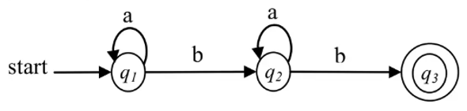
- Construct a DFA equivalent to the NFA . M =({a,b,c,d),(0,1), δ, a,{b,d} where transition is a defined as
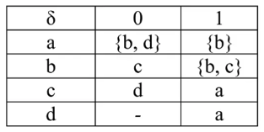
- Reduce the following grammar to Chomsky normal form.
S → A B
A → a a b
B → a A C
- Prove by pumping lemma, that the language 0^{n}1^{n} is not regular.

- Convert the following grammar into GNF.
S → AB1 | 0
A → 00A | B
B → 1A1
- Write a short note on different types of Turing Machine.

PART- C
Answer any TWO questions (10 X 2 = 20)
- a. Construct a minimized automata for the following automata to define
the same language. [6]
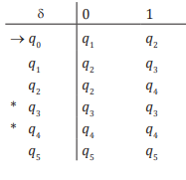
b. Remove the ∈ - production from the following CFG.
S → X Y X X → 0 X | ∈ Y → 1 X | ∈ [4]
- a. Construct a push down automata for the language L={a^{n}b^{n}|≥1} [6]
- Define Turing Machine, Language Acceptance of TM & Instantaneous
Description of TM. [4]
- a. Explain Chomsky Hierarchy of generative Grammars with
examples. [6]
b. Define Regular Expressions and write the properties of regular
expressions. [4]

