REG NO:
DATE:

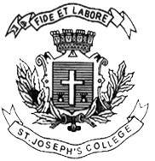
ST. JOSEPH’S COLLEGE (AUTONOMOUS), BENGALURU -27
B.Sc–V SEMESTER
END SEMESTER EXAMINATION: OCTOBER 2023
(Examination conducted in November /December 2023)
CS5223 – COMPUTER NETWORKS
(For current batch students only)

Time: 2 Hours Max Marks: 60
This paper contains two printed pages and two parts.

PART-A
Answer all the questions (2*5=10)
- What is Topology? Mention the advantages and disadvantages of Bus Topology.
- What is Hamming Distance? Compute the hamming distance between the data bits 11110000 and 10101010.
- What is Flow Control? Mention any 2 methods to balance the flow control.
- Differentiate between Aloha and CSMA.
- What is Routing? List any two routing algorithms.
PART B
Answer any five of the following questions (4*5=20)
- With a neat diagram explain TCP/IP layered architecture.
- Compute Cyclic redundancy check code for data bits 11001100 and the divisor 1110.
- Illustrate on Go back n protocol with an example.
- Give the frame format for IEEE 802.3 LAN standard.
- Summarize about Link state routing.
- Write a Java program for Leaky Bucket Congestion Control Algorithm.
- What is Multiplexing? Differentiate FDM with TDM.
PART C
- Answer any three of the following questions (10*3=30) (a)What is Switching? Give the types of Switching. Explain. (6)
(b) Mention the differences between Datagram and Virtual circuit packet switching.(4)
14. (a) Compute the hamming code for the data 1100. (6)
(b) Write a short note on 1-bit sliding window protocol. (4)
15. (a) Explain IEEE 802.11 standard. (6)
(b) What is FDDI? What is the purpose of FDDI? (4)
16. (a) What is shortest path routing? Find the shortest path between the node A and F for the following figure by applying Dijkstra’s algorithm. (6)
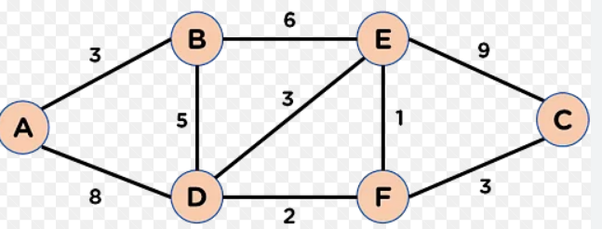

(b) Explain the transmission policies Closed Loop congestion control algorithm.(4)

