**Rectangle 1ST JOSEPH’S UNIVERSITY, BENGALURU -27**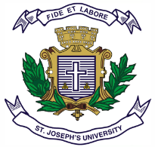

**IV SEMESTER - BA/BCOM/BSC/BBA/BVOC**

**END SEMESTER EXAMINATION: April 2024**

**(Examination conducted in May / June 2024)**

**JNIOE 02 - Insta Thrills : Food and Digital Storytelling skills**

**(For current batch students only)**

**Time: 2 Hours Max. Marks: 60**

**Instructions:**

1. **This paper is for students of II Semester choosing the Open Elective - Insta Thrills : Food and Digital Storytelling skills**
2. **This paper contains FOUR printed pages and THREE parts.**
3. **You may use a dictionary.**
4. **Adhere to the prescribed word counts.**

**Part A**

**Read the following passage and answer any three questions. (3x5 = 15)**

**Digital menu fantasy — storytelling**

Written by Tammy Linn

Fusion cuisine still maintains one of the top dining trends after decades. As an immigrant and an Asian chef trained in Europe, I inevitably joined this field. Two years ago, I worked in one of the luxury hotels in Ibiza and designed the fusion menu. The concept is to combine Asian street food with creative elements. Our plates include Chinese Dim Sum, Thai salad, Vietnamese Pho and spring roll, Japanese rice bowl (Don), and Taiwanese Steam buns (Gua Bao). All mixed with Mediterranean ingredients and creative changes.

Now comes the menu writing part. The concept was to bring the customers to an exotic dining experience. Our leaders were excited about using the original dish names like Jaozi, Oyakodon, Bò Bía and so on. So this example is the menu description looked like:

* **Tang Bao with truffle — — — — — (price)***Homemade Dim Sum filled with Iberian pork and broth, beetroot wrapper, seasoning with truffle oil*
* **Taiwanese Gua Bao — — — — — (price)***Classic pork belly cooked 10 hours at low temperature with caramelised broth, pickled vegetables, lettuce, peanut powder, truffle mayonnaise and homemade sesame steam buns*

After we printed the new menu, problems came.

The waiters struggled with the Asian dishes’ names and the introduction stories. Even I had printed a tutor for everybody, trained, tasting and make sure they had them practised.

The customers were confused with names, too. See how similar the two dishes are in the example above? Only Chinese speakers would not be confused. People who wanted to order Gua Bao ordered the Tang Bao. The waiters could not notice that because the customers ordered without a doubt. It is always a heartbroken moment for chefs, when the dishes which are prepared with lots of time and love, are sent back to the kitchen.

**Photos on the menu?**

Several years ago, Gallup reported that most customers spend an average of 109 seconds reading a menu. During this time, they need to generate the image of the plates from the limited information on the menu:

*“Does the combination sound tasty?”*

*“It reminds me of something I’ve eaten before.”*

*“This food may look like…”*

In Asia, not only street food and low-cost restaurants use photos for customers. Some of the premium casual restaurants show the photos, too. Photos seem to help customers have fully understood the dish even stimulate their appetite. Restaurants can unleash creativity to design the menu with illustrations or exquisite photography.

The disadvantage of photos on the menu is clear: Ruin the imagination of the dish, an argument occurred when the dish looks different than the photo, cost more when changing the menu, and it doesn’t look elegant for high-end restaurants.

Also, don’t get confused.

The story means the background of the food, not the dish photos. Dish photos only help to know what the food looks like, but they still can not express helpful information.

**Difficulties of waiters**

Let’s back to the previous example. Most of the customers who are interested in fusion dining enjoy the sense of multi-culture. But this doesn’t mean they can accept an unimaginable dish. When the customers see the description ingredients, they have no idea how does the dish look like. I’ve suggested adding more descriptions like storytelling about each dish because it can reduce the wrong orders and it shows our professionalism. Also, our customers are on holiday so they would relax reading. But it was rejected as a posh restaurant should let waiters explain everything.

However, many customers are tired of lengthy dish descriptions from the waiters. Many articles about fine dining already pointed out this problem.

Now we know restaurants want to deliver clear information to the customers without ruin their imagination. They want the information match to the customers’ tastes, also some expectations to stimulate their brains.

The customers want the food they will order to match their taste, but they also want a premium dining experience with a surprise beyond their expectations. And they don’t like to read too many texts, they also don’t have the patience of listening to lengthy talks.

**A better storytelling way: Mood board**

**Mood board storytelling is what I imagine of what digital menus can do.**

A mood board is a type of visual presentation or ‘collage’ consisting of images, text, and samples of objects in a composition. It can be based on a set topic or can be any material chosen at random. **A mood board can be used to convey a general idea or feeling about a particular topic. They may be physical or digital and can be effective presentation tools.**

Some graphic designs of the menu or the restaurant interior design already do this job. Using images to show the ingredients, homemade process, and any stories behind. Let’s start from this point. How about the photo of the cooking process? How about the special ingredient of the plate? It doesn’t ruin your imagination. Instead, it helps you draw a picture of the taste.

Here is the example above, see how easy to distinguish two different food?

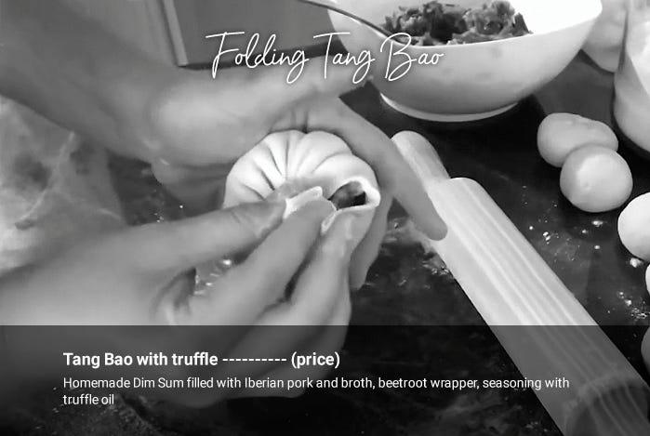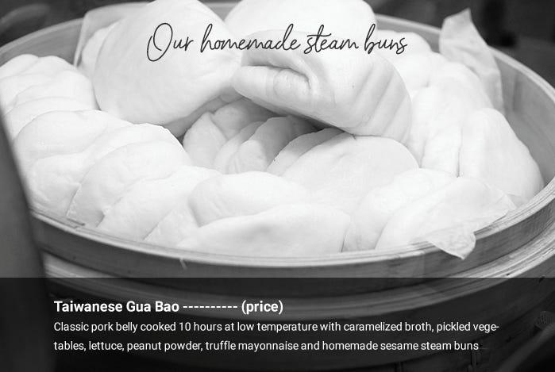

Mood board storytelling can be creative and wow your customers. Ask the marketing colleagues, that’s what they do when they put photos on Instagram. It’s dynamic and flexible. Think about the selling point of the plate and use any image, illustration, phrase, poem, or video to sell it. You can also use it to explain any complicated part and decide how much detail you want to show. As the world starts to digitalise the menus, it’s a good opportunity to improve our menu storytelling. A balance between cheap food photo menus and unclear text menus. If fancy restaurants going to digitalise the menu, this would be a direction.

1. Why do you think that ‘Fusion Cuisine’ remains one of the popular dining trends after decades?
2. What is Mood Board Story telling? Can it work in India?
3. How do you choose food when you visit a restaurant? What are the factors that influence your preferences?
4. Do you find the title to this passage effective? Suggest an alternative title.

**Part B**

**Answer the following questions in 150 words. (3x10=30)**

1. What is community food growing? How does digital story-telling promote community food growing?
2. What is the most interesting food image you have come across online?

1. If you are asked to create a digital story representing the food culture of your place /state, what would be the two dishes that you would choose? Why?

**Part C**

**Answer the following question in about 200-250 words (15 marks)**

1. Digital culture has significantly altered culinary culture in contemporary times. Do you agree with this statement? Has social media has influenced your food choices in any way?