 Reg No :
Date:
ST. JOSEPH’S COLLEGE(AUTONOMOUS), BENGALURU-27
BCA- VI SEMESTER
SEMESTER EXAMINATION: APRIL 2024
(Examination Conducted in May/June 2024)
CA6223-ARTIFICIAL INTELLIGENCE AND APPLICATIONS

(For current batch students only)
Time- 2 hrs
Max Marks-60

This paper contains 3 printed pages and 3 parts
PART A
Answer all of the following (2x5=10)

- What is Heuristic Function? How does the quality of a heuristic function affect search algorithms?
- What is Local Maxima?
- Differentiate uninformed and informed search?
- Differentiate predicate and propositional logic. How to convert propositional statement to CNF.
- What are the stages in the development of expert system tools?

PART B
Answer any Five of the following (4x5=20)

- What is production system? Explain the characteristics of production system.
- Explain the steps of A*algorithm. What are some common applications of A* search?
- Explain the difference between the means and the ends in means-ends analysis.
Provide a brief example illustrating the application of means-ends analysis in a problem-solving scenario.
- What is alpha-beta pruning? Explain the function of alpha-beta pruning.
- Translate the following statement into FOPL. (2+2)
- Everyone who saves money earns interest.
- If there is no interest, then nobody saves money.
- Elaborate on different types learning with examples.
- Draw a semantic network for the following statements.
- Car is a vehicle.
- Toyota Corolla is a car.
- Bicycle is a vehicle.
- Toyota corolla has wheels.
- Bicycle has wheels.

PART C

Answer any Three of the following questions (10x3=30)

13. a) Elaborate artificial intelligence with suitable example along with it’s application. (4 marks)
b) Using hill climbing algorithm find the shortest path where "a" is initial and h and k are final states and the numbers near the states are the heuristic values for the tree given below.
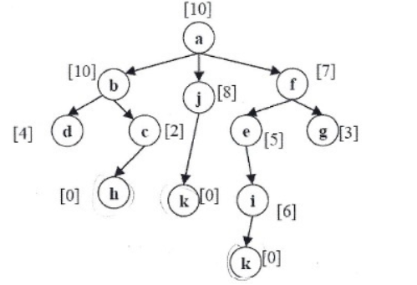
(6 marks)

14.a) Consider the following game tree in which static evaluation score are all from the
players point of view: static evaluation score range is (+10 to -10)

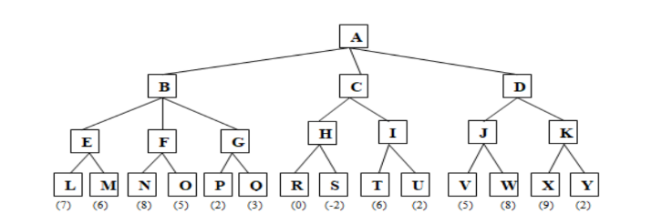

Suppose the first player is the maximizing player. What move should be chosen?
(7marks)
b) Illustrate the usage of heuristic in Minimax procedure. (3 marks)
15.
a) Give outline of resolution algorithm. Consider the set of clauses:

A ∨ B
¬B ∨ C
¬C ∨ D
Apply resolution to show the validity of the conclusion A ∨ D. (7 marks)
b) Describe the role of unification in the resolution process. (3 marks)

16. a) Differentiate forward and backward reasoning. (Forward and
backward chaining) . ( 5 marks)

b) With neat sketch explain the architecture, characteristic features and roles
of expert system. (5 marks)

******************************************************************************************

