 Reg No:
Date:

ST. JOSEPH’S UNIVERSITY, BENGALURU-27
MSc COMPUTER SCIENCE -II SEMESTER
END SEMESTER EXAMINATION :APRIL 2024
(Examination Conducted in MAY /JUNE 2024)
CS8221-MACHINE LEARNING USING PYTHON
(For current batch students only)
Time- 2 hrs |  |  | Max Marks-50
This paper contains 2 printed pages and three parts.

PART A
Answer all of the following (2x5=10)

- Discus the various steps involved in designing a learning system.
- Define the terms underfitting and overfitting in the context of machine learning models. How can these issues be addressed?
- Discuss the advantages and disadvantages of hierarchical clustering compared to K-means clustering.
- Explain the term Gradient Descent.
- How can you perform array indexing and slicing in NumPy?

PART B
Answer any Five of the following (4*5=20)

- What is Dimensionality Reduction? Explain the significance of Dimensionality Reduction.
- Explain agglomerative clustering. Compare and contrast the different measures used to calculate the distance between clusters.
- Analyze the structure of a decision tree built from a dataset. Identify the key nodes and branches, and explain how the decision tree partitions the feature space.

- You are given a dataset containing sequences of observations and corresponding hidden states. Explain how you would train a Hidden Markov Model (HMM) using this dataset.
- Explain the goal of support vector machine(SVM)?How to compute the margin?

- Elaborate the following in pandas
- How can you read a CSV file into a Pandas Data Frame? (2 marks)
- Explain the process of merging two Pandas Data Frames. (2marks)
- Write a python program to develop a linear regression model using scikit package.

PART C

Answer any Two of the following questions (10* 2=20)

- a) You are given a dataset with 10 features. Explain how you would use PCA to reduce the dimensionality of this dataset to 3 dimensions. Include the steps involved, such as data preprocessing, eigen decomposition, and dimensionality reduction.
(6 marks)
b) How does dimensionality reduction using PCA affect the performance of various machine learning models? Provide examples or scenarios to support your answer. (4 marks)
- a) Describe the concept of entropy as used in the ID3 algorithm. (2 marks)

b) Given a dataset containing various features of weather conditions classify whether we can enjoy sport on a given day (new instance)using the Naive Bayesian classification algorithm.

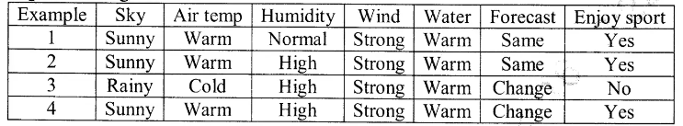
(8 marks)
- a) Describe the steps involved in the forward pass and backward pass of the backpropagation algorithm. Provide a detailed explanation of each step and its role in training a neural network. (6marks)
b) Identify the elements of reinforcement learning. (4 marks)

******************************************************************************************

