
REG NO:
DATE:

ST. JOSEPH’S UNIVERSITY, BENGALURU -27
M.Sc(Computer Science) – IV SEMESTER
SEMESTER EXAMINATION: APRIL 2024
(Examination conducted in May-June 2024)
CS 0122: IMAGE PROCESSING
(For current batch students only)

Time: 2 Hours Max Marks: 50
This paper contains two printed pages and three parts.

PART A
ANSWER ALL THE FOLLOWING QUESTIONS. (2*5 =10)
- Define Digital Image and pixel of an image?
- What is histogram? Explain histogram equalization..
- What is Image enhancement? Mention the categories of image enhancement.
- How a degradation process is modeled?.
- Write the importance of Eigen values and Eigen vectors.
PART B
ANSWER ANY FIVE OF THE FOLLOWING QUESTIONS. (4*5=20)
- Explain Neighbouring of pixels(4 neighbouring and 8 Neighbouring and Diagonal).
- Demonstrate the process of RGB color model to HSI color model conversion
- Explain power law transformation.
- Explain region growing method in detail for image segmentation.
- Demonstrate Opening and closing Morphological operations with neat diagram.
- Demonstrate Histogram equalization of image of 3bit image of size 64X64 for the following Histogram.
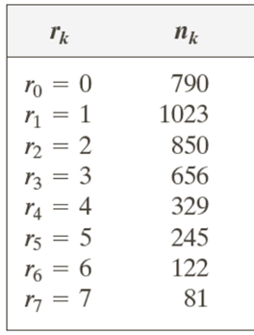
- Explain erosion and dilation.

PART C
ANSWER ANY TWO OF THE FOLLOWING QUESTIONS. (10*2=20)
- a) Desribe fundamental steps in image processing. (5 Marks)
b) Explain thinning morphological operation. (5Marks)
- (a) Analyze non-linear(Order-Static) filter in terms of smoothening. (8 Marks)
(b) What is pseudocoloring? Describe it using Intensity slicing with neat diagram(2 Marks)

- (a) Explain Bitplane Compression with suitable example. (5 Marks)
(b) Compare and Contrast between Lossy and Lossless compression techniques. (5Marks)

