
REG NO:
DATE:

ST. JOSEPH’S UNIVERSITY, BENGALURU -27
M.Sc(Computer Science) – IV SEMESTER
END SEMESTER EXAMINATION: APRIL 2024
(Examination conducted in May-June 2024)
CS 0222: ADVANCED OPERATING SYSTEM
(For current batch students only)

Time: 2 Hours Max Marks: 50
This paper contains two printed pages and three parts.

PART A
ANSWER ALL THE FOLLOWING QUESTIONS. (2*5 =10)
- Define process synchronization. What is Critical Section?
- What are the benefits of Synchronous and Asynchronous Communication.
- Differentiate between Load Balancing and Load Sharing.
- Give the classification of System Failures.
- How does the Master Slave configuration of Multiprocessor Operating Systems differ from other Configuration?
PART B
ANSWER ANY FIVE OF THE FOLLOWING QUESTIONS. (4*5=20)
- Discuss concurrent and cooperating processes using Producer Consumer Problem.
- How Logical clock can be updated under Lamport’s Scheme? What are the limitations of Lamport’s Logical clock? Explain it using the following example:
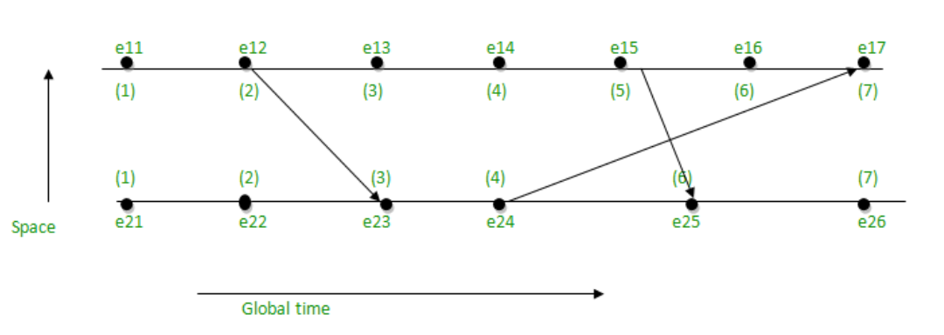

- Suggest some solutions for the Byzantine Agreement problems.
- What is Memory Coherence in Distributed Shared Memory?
- Write short notes on:
- Orphan Messages
- Domino Effect
- What are the advantages of user level thread and kernel level thread?
- Discuss about any 4 design issues of Distributed File system.

PART C
ANSWER ANY TWO OF THE FOLLOWING QUESTIONS. (10*2=20)
- (a) Illustrate with a neat diagram the different states of a process.
(b) In the following Wait for graph, Check whether there exists a deadlock or not? If
Yes, how to handle the deadlock.

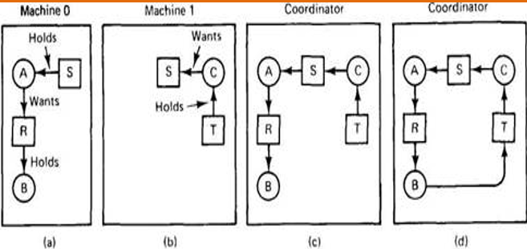
[5+5]

- (a) “Symmetrically initiated algorithms have the advantage of both Sender initiated and receiver initiated distributed scheduling algorithm”. Justify the statement.
(b) Explain in detail about the rollback recovery algorithm. [5+5]

- (a) Write in detail about three phase commit protocol with an example.
(b) Explain the type of resources and types of resource accesses. [5+5]

