
Registration Number:
Date & Session

ST. JOSEPH’S COLLEGE (AUTONOMOUS), BENGALURU -27
B.Sc (COMPUTER SCIENCE)–VI SEMESTER
END SEMESTER EXAMINATION: APRIL 2024
(Examination conducted in May/June 2024)
CS6223 – OPERATING SYSTEM
(For current batch students only)

Time: 2.0 Hours Max Marks: 60
This paper contains three printed pages and two parts.

PART-A

Answer all the questions (2*5=10)
- What is an operating System? Mention any three characteristics.
- Define a process and a thread.
- Illustrate process synchronization.
- Differentiate between Logical address and Physical address.
- What is a File? List its attributes.

PART B
Answer any five of the following questions (4*5=20)
- Compare and Contrast between Real Time and Distributed Operating System.
- Consider the set of 5 processes whose arrival time and burst time are given below-
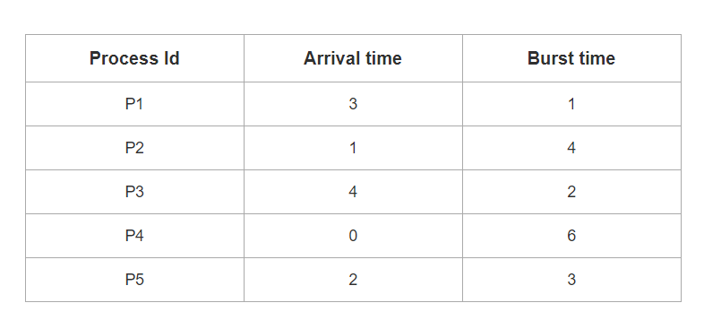
If the CPU scheduling policy is SJF Preemptive, calculate the average waiting time and average turnaround time.
- What constitutes a deadlock, and what are the necessary circumstances for a deadlock to occur?
- A system uses 3 page frames for storing process pages in main memory. It uses the First in First out (FIFO) page replacement policy. Assume that all the page frames are initially empty. What is the total number of page faults that will occur while processing the page reference string given below-?
4 , 7, 6, 1, 7, 6, 1, 2, 7, 2
Also calculate the hit ratio and miss ratio.
- Explain about the disk structure of a File system.
- Outline on the components of modern computer system.
- Write Short notes on:
(a)Virtual Memory.
(b)Semaphores.
PART C
Answer any three of the following questions (3*10=30)
- (a) Label the States of a process in detail. (4 marks)
(b) Consider the set of 6 processes whose arrival time and burst time are given below-
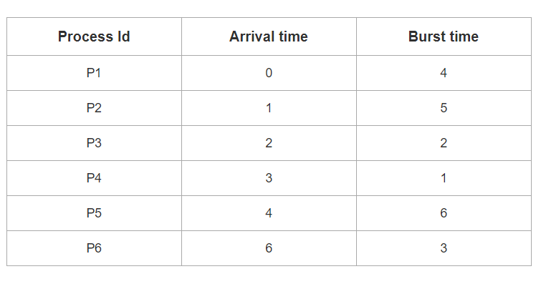
If the CPU scheduling policy is Round Robin with time quantum = 2, calculate the average waiting time and average turn around time. (6 marks)
- (a) With the help of pseudocode, explain Dining philosopher problem using semaphore. .(6 marks)
(b) Explain about deadlock prevention in a process management setup. (4 marks)
15. (a) Elaborate on the fundamental approach for implementing the Paging Concept (6 marks)
(b) Summarize the concept of Demand paging in memory management. (4 marks)
16. (a) Differentiate between Sequential and Random File access methods. (4 marks)
(b) Consider a disk queue with requests for I/O to blocks on cylinders 98, 183, 41, 122, 14, 124, 65, 67. The SSTF scheduling algorithm is used. The head is initially at cylinder number 53 moving towards larger cylinder numbers on its servicing pass. The cylinders are numbered from 0 to 199. The total head movement (in number of cylinders) incurred while servicing these requests is _______.[.(6 marks)

*************************************************************************************************************

