

Registration Number:

Date & Session:

**ST. JOSEPH’S UNIVERSITY, BENGALURU -27**

**B.A THEATRE & PERFORMANCE STUDIES –2nd SEMESTER**

**ENDSEMESTER EXAMINATION: MARCH 2024**

**TS 221: THEATRE & PERFORMANCE STUDIES**

**Time: 2 Hours Max Marks: 60**

**Instructions:**

1. **This question paper has TWO pages and THREE sections**
2. **You will lose marks for exceeding the word limit.**
3. **Here is a picture from the stage production of *Nagamandala* performed in 1989. Examine it carefully.**

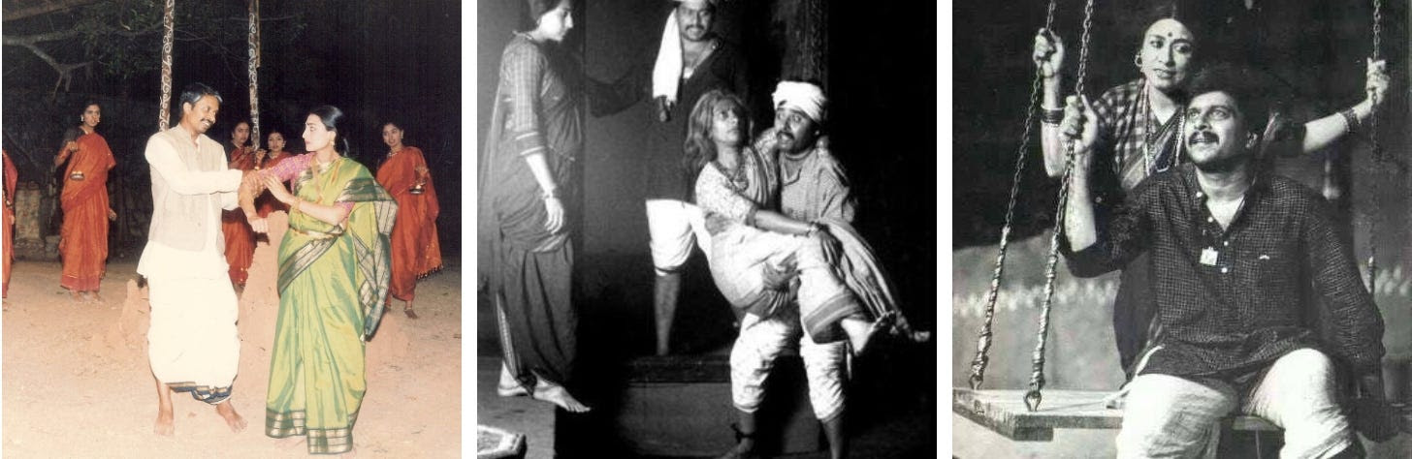

1. **Answer the following questions in FIVE-EIGHT sentences each. (3x5=15)**
2. How is the Kappanna-Kurudavva duo visualized differently here than the way Karnad imagined it? Which one has a shaper stage impact? Explain.
3. All three pictures show us that the play was performed in an open space. What moments in the play do you think would suffer if the play were to be performed in a closed space such as the auditorium? Quote specific scenes from the play.
4. The swing appears to be a new addition in this adaptation of the play. Explore its possibilities as a prop in relation to ANY TWO characters from *Nagamandala*.
5. **Answer the following questions in 100-150 words. (3x10=30)**
6. What are some mistakes you’ve seen classmates or other performers do on stage? How do you suggest they avoid it? Explain with examples from plays watched this semester.
7. As a text, does *Nagamandala* read like an English translation of a Kannada play or an English play itself? Quote specific words from the play you found interesting for the way they were used.
8. Imagine you were adapting Nagamandala for stage with the help of ONLY ONE prop. Which prop from the text would you like to retain and why? How would it be used by characters on stage? How do you see the audience interacting with it? Explain.
9. Kurudavva and Rani – an alternative ending to *Nagamandala*. Explore. You are free to rewrite/kill/exclude other characters. **Write a short scene not exceeding two pages** with dialogues, stage directions, and narration.  **(15 marks)**

**\*\*\*\*\*\*\*\***