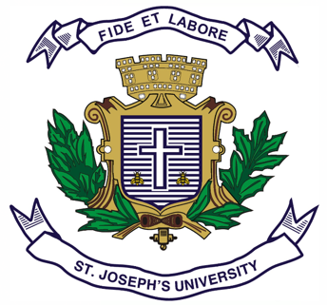**ST.JOSEPH’S UNIVERSITY, BENGALURU-27**

Registration Number:

Date & session:

**OPEN ELECTIVE (HISTORY) – II SEMESTER**

**SEMESTER EXAMINATION: APRIL 2024**

**(Examination conducted in May /June 2024)**

**HSOE2: MAKERS OF MODERN INDIA**

**(For current batch students only)**

**Time: 2 Hours Max Marks: 60**

*This question paper has 1 printed page and 2 parts*

**SECTION - A**

**Answer any 10 of the following (2 x 10 = 20)**

1. Note down the literary contributions of Raja Ram Mohan Roy.

2. Mention the seminal work of Jyotiba Phule and mention how he was different from other reformers.

3. Who authored ‘Malgudi Days?’ Highlight the implicit issues associated with it.

4. Name any two women social reformers of the 19th century and their works.

5. What were the contributions of Aruna Asaf Ali during the Quit India Movement?

6. Why is Sardar Patel known as the Unity Man?

7. What is the role of Pandita Ramabai in the reformation era?

8. Who founded the Theosophical Society? How is Annie Bessant connected to this association?

9. What are the three books authored by Nehru before Independence?

10. Who called Tagore ‘The Poet of Asia?’ Substantiate that title by giving an example.

11. When is National Education Day? What is its significance?

12. What is BARC? What was the other name for India’s first successful nuclear test, and where was it held?

**SECTION - B**

**Answer any 4 of the following (10 x 4 = 40)**

13. Despite 20 years of intense personal and political rivalry with Congress, when India became independent, Ambedkar was offered the job of law minister. What made Ambedkar different? Comment on this move by evaluating the current political scenarios.

14. Is it correct to say that Jayaprakash Narayan is noted for his role in two Quit India Movements? Explain, looking at his life and contributions.

15. Swami Vivekananda brought a new life to the Indian Reformation Movement. Discuss.

16. Discuss the three political experiments of Mahatma Gandhi in India and how his ideologies shaped the Indian freedom struggle.

17. ‘Bala Gangadhar Tilak was an ardent Hindu Nationalist.’ In this context, explain his role in the Indian National Movement.

18. Discuss the rise of APJ Abdul Kalam as the ‘Missile Man of India.’