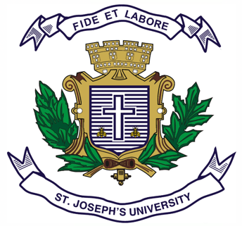**ST.JOSEPH’S UNIVERSITY, BENGALURU-27**

Registration Number:

Date & session:

**B.A. (HISTORY) – IV SEMESTER**

**SEMESTER EXAMINATION: APRIL 2024**

**(Examination conducted in May /June 2024)**

**HS 4122: MAKERS OF MODERN INDIA**

**(For current batch students only)**

**Time: 2 Hours Max Marks: 60**

*This question paper has 1 printed page and 4 parts*

**SECTION - A**

**Answer any 2 of the following (2 x 10 = 20)**

1. Illustrate the contributions of Raja Ram Mohan Roy to Modern India.

2. Explain the role played by Mahatma Gandhi in India’s freedom struggle.

3. Discuss the contributions of Dr B.R. Ambedkar towards the upliftment of the Dalits.

**SECTION - B (5 + 5 = 10)**

4. Mark on the outline map provided the following places and write their historical importance. 1. Erode 2. Allahabad 3. Rameshwaram 4. Calcutta 5. Adyar

**SECTION - C**

**Answer any 4 of the following (5 x 4 = 20)**

5. Sketch the activities of the Ramakrishna Mission.

6. Why is EV Ramaswamy Naicker called Periyar? Discuss.

7. Explain the role played by Sardar Vallabhai Patel in creating a New India.

8. Narrate the contributions of Dr. Homi Jehangir Baba to Indian Science.

9. Discuss the contributions of R K Narayan to English literature.

10. Mention the role of Aruna Asaf Ali in the freedom struggle of India.

**SECTION - D**

**Answer any 5 of the following questions (2 x 5= 10)**

11. Name two places associated with salt satyagraha.

12. When and where was Jawaharlal Nehru born?

13. Write any two names of the books written by Jyotiba Phule.

14. What were the two key demands of Bal Gangadhar Tilak?

15. Which University was started by Sir Syed Ahmed Khan? In Which state of India?

16. Who is the missile man of India? Where was he born?

17. Who started the Total Revolution? Why?