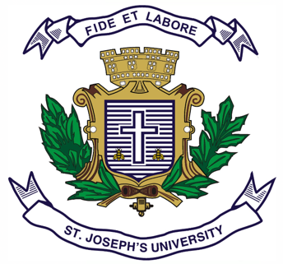
ST.JOSEPH’S UNIVERSITY, BENGALURU-27
Registration Number:
Date & session:
OPEN ELECTIVE (HISTORY) – IV SEMESTER
SEMESTER EXAMINATION: APRIL 2024
(Examination conducted in May /June 2024)

HSOE 4: CULTURAL HERITAGE OF INDIA
(For current batch students only)
time: 2 hrs. Max. MARKS: 60
This question paper has 1 printed page and 2 parts.

SECTION – a
Answer any 10 of the following questions (2 x 10= 20)
- What is cultural heritage?
- Write a note about the Christmas celebrations in Goa, Diu and Daman.
- What is the astronomical significance of Pongal?
- Name the four places associated with the Kumbha mela.
- What are the mask dances of Ladakh called? Name the tradition they followed.
- Which text is considered the magnum opus of classical dance? Name the author.
- Name the epic to which Manipuri dance is related.
- Who promoted the Ghoomar dance in Rajasthan?
- What is Harikatha? Name the states where this is performed.
- Who is known as the trinity of Carnatic music?
- What is a Stupa? Name any two stupas.
- Name the two heritage sites of India added to the list of UNESCO World Heritage Sites in 2023.

SECTION - B
Answer any 4 of the following questions (10 x 4 = 40)
- What is Culture? Explain the general characteristics of a culture.
- What is Dasara Utsav? Describe the celebrations associated with it.
- Give an account of the Puri Rath Yatra.
- Mention the classical dances of India. Write a note on any one of them.
- What is Sufism? Explain the significance of music associated with it.
- Name the different styles of architecture. Describe the South Indian style of architecture with suitable examples.

*****************

