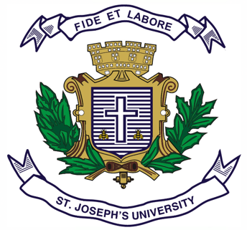

**ST.JOSEPH’S UNIVERSITY, BENGALURU -27**

**B.A. INDUSTRIAL RELATIONS- II SEMESTER**

**SEMESTER EXAMINATION: APRIL 2024**

**(Examination Conducted in May 2024)**

**IR 2221: COMPENSATION AND BENEFITS MANAGEMENT**

**(For Current batch and Supplementary students)**

**Time: 2 Hours Max Marks: 60**

**This paper contains TWO printed pages and THREE parts**

**PART-A**

**Answer any TEN questions: (10x2=20)**

**1**. What do you mean by Compensation Management?

2. Give the meaning of the term “Minimum Wage “.

3. What is Dearness Allowance?

4. What are the other two names given for Compensation Management?

5. What is employee bonus?

6. Who is the Chairman of 7 th Pay Commission?

7. What is Cafeteria Compensation?

8. In which year was the Minimum wages Act enacted in India?

9. List two incentives offered to sales personnel working in retail outlets.

10. Write the meaning of Time wage plan?

11. Expand MNC.

12. When does financial year Begin and End in India?

**PART-B**

**Answer any FIVE questions: (5x5=25)**

13. Write Short notes on Piece Wage plan.

14. Name any four components of Pay Packet and explain any one of them

15. Write Short notes on various problems faced by both employers and employees with special reference to wages during the COVID-19 Pandemic.

16. Write short notes on Income Tax in India.

17. What is role of Wage Boards in India?

18. Briefly explain the concept of Basic Wages.

19**.** What are the pre requisites of effective incentive plan?

**PART-C**

**Answer any ONE question: (1x15=15)**

20. Write an Essay on any Two Wage Theories OR Give details of the following:

a. Fair Wages

b. Living Wages

c. Minimum Wages

21. Write an Essay on any Two Types of D.A. Payment.