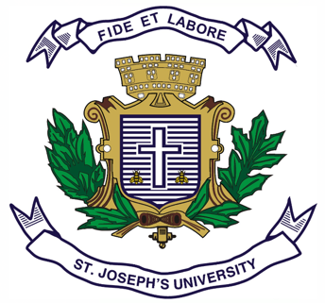

**ST.JOSEPH’S UNIVERSITY, BENGALURU -27**

**B.A. INDUSTRIAL RELATIONS- OPEN ELECTIVE – II SEMESTER**

**SEMESTER EXAMINATION: APRIL 2024**

**(Examination conducted in May 2024)**

**IROE 2: INTRODUCTION TO LABOUR WELFARE IN INDIA**

**(For Current batch and Supplementary students)**

**Time: 2 Hours Max Marks: 60**

**This paper contains TWO printed pages and THREE parts**

**PART-A**

**Answer any TEN questions: (10x2=20)**

1. What is the meaning of Industry?
2. Expand I.L.O. In which was I.L.O established?
3. Define Labor Welfare.
4. Who coined the term Industrial Relations?
5. Define Job Stress.
6. What is QWL?
7. Name the present Labor Minister of India.
8. Name any two Occupational Diseases
9. Name any two Indian Freedom Fighters who have also worked for Labor Welfare in India
10. What is Byssinosis?
11. What is Chemical Hazard?
12. What is Industrial Safety?

**PART-B**

**Answer any FIVE questions: (5x5=25)**

13. What is the nature and scope of Industrial Relations?

14. Write short notes on Industrial Accidents

15. Write short notes on Labor welfare and its merits

16. What are few strategies to improve QWL?

17. Write short notes on statutory and non-statutory labor welfare measures in India

18. Write short notes on “Elimination of Child Labor in India”.

19. Write short notes on the problems faced by health workers during COVID-19

Pandemic (2020-2021).

**PART-C**

**Answer any ONE question: (1x15=15)**

20. Write an essay on various Occupational Hazards and its effects on Labor

21. What is Job stress and what are the various reasons for the same, and measures to tackle Job stress?