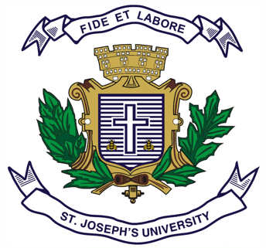

Registration Number:

Date & session:

**ST JOSEPH’S UNIVERSITY, BENGALURU -27**

**OPEN ELECTIVE – 2nd SEMESTER**

**SEMESTER EXAMINATION: APRIL 2024**

**(Examination conducted in May / June 2024)**

**PSOE - 221: INDIAN POLITY – ISSUES AND CONCERNS**

**(For current batch students only)**

**Time: 2 Hours Max Marks: 60**

**This paper contains 01 printed page and 03 parts**

**PART-A**

1. **Answer any five of the following questions in about 30 – 40 words each. 5X3=15**
2. What is National Integration?
3. What is Secularism?
4. What is Development?
5. What is “sons of soil doctrine”?
6. What is right to Religion?
7. What is Terrorism?
8. What is Unity in Diversity?

**PART-B**

1. **Answer any three of the following questions in about 150 – 200 words each. 3X7=21**
2. Discuss the challenges in the Nation Building process.
3. What is Communalism? Bring its impact on democracy.
4. Discuss the measures initiated by the government towards the inclusive growth.
5. Comment on three language formula.
6. What is Corruption? What are the measures initiated to eradicate Corruption.

**PART-C**

1. **Answer any two of the following questions in about 250 – 300 words each. 2X12=24**
2. Critically analyse the impact of Caste system in modern India.
3. Elucidate on the reasons for the growth of regionalism and measures to address it.
4. What do you mean by celebrating diversity? Bring out the challenges in celebrating diversity.