ST JOSEPH’S UNIVERSITY, BENGALURU-27
II B.Sc., BOTANY – IV SEMESTER
SEMESTER EXAMINATION: APRIL 2024
(Examination conducted in May/June 2024)
BY423: BIOLOGY IV

(For current batch students only)
Time: 2 Hours Max Marks: 60

This paper contains THREE printed pages and TWO parts.
Each part has to be answered on separate answer booklets.
Draw diagrams and write examples wherever necessary.

PART ONE – BOTANY

- Answer ANY FIVE of the following in two or three sentences 5 × 2 = 10
- What is Binomial nomenclature?
- What is a cremocarp?
- Explain spadix inflorescence.
- What is pappus?
- Explain resupination.
- Explain DNA barcoding.
- Botanical name and family of Cotton.

- Write critical notes on ANY TWO of the following 2 × 5 = 10
- A) State ICN principles (any 2)
B) Explain any 3 types of sepal aestivation.
- Salient features of the family Solanaceae.
- Explain the role of Palynology in plant taxonomy.

- Give a comprehensive account of ANY ONE of the following 1 × 10 = 10
- a) Diagnostic characters of the family Euphorbiaceae
b) Herbarium technique
- a) Assign the unique character to its respective family
Characters: cruciform corolla; oil dotted glands; coronary corona; intrapetiolar stipules; pepo.
Family: Apocynaceae; Cucurbitaceae; Brassicaceae; Rubiaceae; Rutaceae.

PTO

b) Identify the family, explain the flower characters based on the floral diagram given and derive the floral formula.
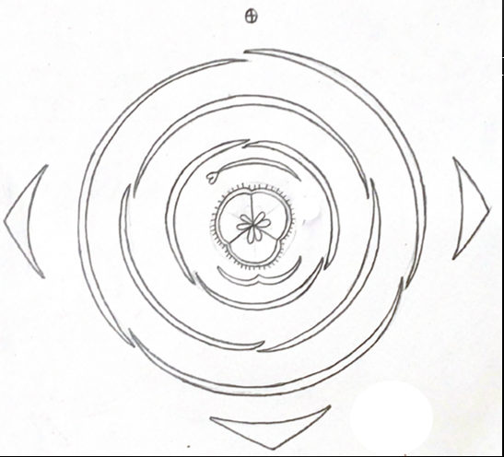

PART TWO – ZOOLOGY

- Answer ANY FIVE of the following in two or three sentences 5 × 2 = 10

- Mention any two unique morphological features of the animal in the image given below
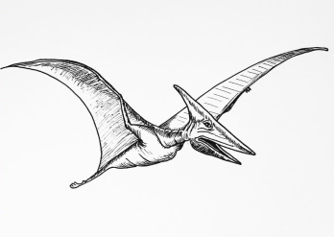
- Archaeopteryx is called as a connecting link. Give any two reasons.
- The Mysore district police in Karnataka apprehended three men for allegedly smuggling ambergris worth Rs.25 Cr. Concerning this, why ambergris is so valued? Where is it obtained from?
- What purpose does Retea Mirabile and Dorsal blowhole serve in cetaceans?
- Write a note on the significance of medulla oblongata in mammals.
- Enlist the four types of snake venom.
- Identify the bone in the image given below and mention two of its funcions
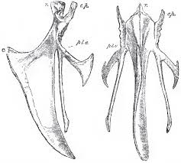

- Write critical notes on ANY TWO of the following 2 × 5 = 10

- What is the advantage of having the four chambered heart? How do amphibians compensate for the disadvantage of having three chambered heart?
- Give the outline classification of mammals up to infra class with examples and mention any two differences between the infra classes.
- Define migration and explain the factors controlling migration in birds.

- Give a comprehensive account of ANY ONE of the following 1 × 10 = 10

- Trace the trends in evolution of the cerebral hemispheres in shark, frog, lizard, bird and mammal. Supplement with sketches of the same.
- Discuss the origin and evolution of mammals.

BY_423_A_2024

