Registration Number:

Date & session:

**ST. JOSEPH’S UNIVERSITY, BENGALURU - 27**

**M.Sc (MICROBIOLOGY) – 2nd SEMESTER**

**SEMESTER EXAMINATION: APRIL 2024**

**(Examination conducted in May-June 2024)**

**MBDE 8521- AGRICULTURAL MICROBIOLOGY**

**(For current batch students only)**

**Time: 2 hours Max Marks: 50**

**This question paper contains 2 printed pages and four parts**

**I. Answer any Five of the following 5X3=15**

1. Write a note on Phytotoxins.

2. What are the causal organisms of the following diseases:

a. Damping off b. White rust of Crucifer c. Tikka disease of groundnut.

3. Is genetic engineering required to uplift the agricultural sector? Comment.

4. List the importance of crop rotation.

5. How do the host exudates influence pathogen interaction?

6. What is the role of systemic fungicide? Give an example.

7. Name a PSM and state its importance.

1. **Answer any Two of the following 2X5=10**

8. Discuss the production of spawn.

9. Write a note on Hypersensitivity in plants.

10. What is AMF? Describe its interaction and importance.

**III. Answer any Two of the following 2X10=20**

11.a. What are biocontrol agents and what are their significance in agricultural sustainability? **7**

b. List the strategies involved in IPM. **3**

12. Describe the life cycle, symptoms, and control of Ergot of rye.

13. Explain the process of biogas production in an anaerobic digester and the microbial role in biogas production.

**IV. Answer the following 1X5=5**

14. Observe the graph below showing the disease progression of late blight of

potato and answer the questions that follow:

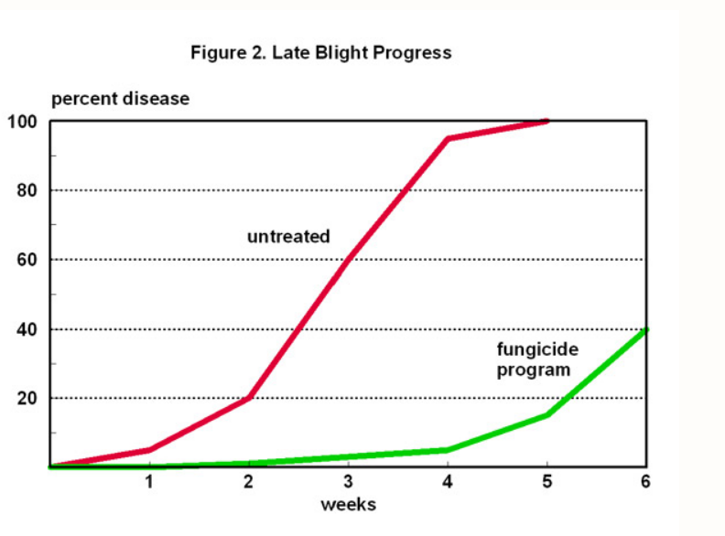

1. Name the causal organism of the Late blight of Potato. 1
2. What does the graph above indicate about the control of the disease? 2
3. List three differences between early and late blight. 2