**ST JOSEPH’S UNIVERSITY, BENGALURU -27**

Registration Number:

Date & session:

**M.Sc (ZOOLOGY) – 2nd SEMESTER**

**SEMESTER EXAMINATION: APRIL 2024**

**(Examination conducted in May / June 2024)**

**ZO 8522 – ENTOMOLOGY**

**(For current batch students only)**

**Time: 2 Hours Max Marks: 50**

**This paper contains 2 printed pages and 4 parts**

**PART-A**

**Answer ALL of the following: 5 x 1 = 5**

1. What are Carbamates?
2. Briefly explain the term Stifling
3. What is the Stadium phase?
4. Give the wing modification in Coleopterans.
5. Identify the following pictorial scenario.

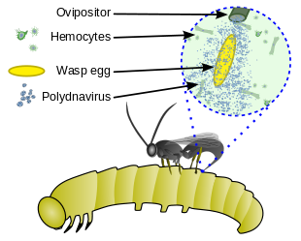

**PART B**

**Answer the following 5 x 2 = 10**

1. What are the roles of insects in forensic sciences?
2. Give two insect pests of fruit and vegetable crops.
3. Dispersal plays a great role in insect population dynamics**.** Explain.
4. Detoxification is a life-threatening process to insects. Comment.
5. How is sex determination different in insects?

**PART C**

**Answer any THREE of the following 3 x 5 = 15**

1. What are semiochemicals?
2. What role does an antennae play in an insect? How would an insect survive if the antennae are severed or cut?
3. Explain mechanism of insecticide resistance.
4. Explain with a diagram the gas exchange in insects. How does a spray of insecticide affect the insect?
5. Bio-pesticide is a novel approach to pest management. Discuss the types.

**PART D**

**Answer any TWO of the following 2 x 10 = 20**

1. Illustrate with diagrams the reproductive systems in insects. Discuss the role of pheromones in reproduction.
2. What is IPM and how is it a better drift in agriculture/horticulture? Add a note on exotic species in the same.
3. Elaborate the occurrence symptoms and control of Yellow fever and Malaria. Discuss the initiatives taken by the government in this aspect.

**\*\*\*\*\*\*\***