
Register Number:
Date: XX/04/2020

ST. JOSEPH'S COLLEGE (AUTONOMOUS), BENGALURU-27
M.Sc. Food Science and Technology- II Semester
SEMESTER EXAMINATION: APRIL 2020
FST 2419-FOOD BIOTECHNOLOGY

Time: 2 ½ hours Max. Marks: 70
This paper contains 1 printed page and 4 parts

I. Answer any five of the following 5x3=15
1. What is Molecular cloning?
2. Highlight the importance of Nutrigenomics.
3. Define Gene mapping.
4. Write a note on Population genetics.
5. List the health benefits of fermented foods.
6. What is Baker’s Yeast?
7. Write a note on Sauekraut.

II. Answer any five of the following 5x5=25

8. List the types and applications of Immobilization of cells.
9. What are mutations? List the types and Write notes on any one.
10. Discuss Slurry Processing.
11. Describe the production of Citric acid.
12. Discuss the production of SCP using Yeast.
13. Give the production of Yoghurt and its importance.
14. Write notes on Golden rice, giving its impact and failure.

III. Answer any two of the following 2x10=20
15. Write detailed notes on Biosensors used in food industries.
16. Discuss the process of Cell disruption by Physico-mechanical methods.
17. Describe the production of Cheddar cheese.

IV. Answer the following 1x10=10
18. Calgene first marketed an unsuccessful product and after which many other crops subjected to gene manipulation has found its way to the consumers. Identify and describe the technique used. What are its limitations and challenges? Discuss

St. Joseph's college (Autonomous), Bengaluru-27
II Semester M.Sc. Food Science and Technology
Paper IV Subject code FST 2419
FOOD BIOTECHNOLOGY
SCHEME

I. Answer any five of the following 5x3=15
1. What is Molecular cloning: definition and process: 03 marks: Molecular cloning is a set of methods, which are used to insert recombinant DNA into a vector - a carrier of DNA molecules that will replicate recombinant DNA fragments in host organisms. The DNA fragment, which may be a gene, can be isolated from a prokaryotic or eukaryotic specimen. Following isolation of the fragment of interest, or insert, both the vector and insert must be cut with restriction enzymes and purified. The purified pieces are joined together though a technique called ligation. The enzyme that catalyzes the ligation reaction is known as ligase.

2. Highlight the importance of Nutrigenomics: importance: 03 marks: Nutritional genomics, also known as nutrigenomics, is a science studying the relationship between human genome, nutrition and health. People in the field work toward developing an understanding of how the whole body responds to a food via systems biology, as well as single gene/single food compound relationships. Nutrigenomics also seeks to provide a molecular understanding of how common chemicals in the diet affect health by altering the expression of genes and the structure of an individual's genome. The premise underlying nutrigenomics is that the influence of diet on health depends on an individual's genetic makeup.

3. Define Gene mapping: definition and use: 03 marks: Gene mapping describes the methods used to identify the locus of a gene and the distances between genes. The essence of all genome mapping is to place a collection of molecular markers onto their respective positions on the genome. Genetic maps are species-specific and comprised of genomic markers and/or genes and the genetic distance between each marker. These distances are calculated based on the frequency of chromosome crossovers occurring during meiosis, and not on their physical location on the chromosome. Gene mapping is a powerful tool that allows geneticists to identify genes that cause Mendelian disease, pinpoint loci for beneficial traits, and to compile and refine reference genomes for any species.

4. Write a note on Population genetics: definition and significance: 03 marks: Population genetics is the study of genetic variation within populations, and involves the examination and modelling of changes in the frequencies of genes and alleles in populations over space and time. In natural populations, however, the genetic composition of a population's gene pool may change over time. provides the deepest and clearest understanding of how evolutionary change occurs. Population genetics is particularly relevant today in the expanding quest to understand the basis for genetic variation in susceptibility to complex diseases. The four factors that can bring about such a change are: natural selection, mutation, random genetic drift, and migration into or out of the population.

5. List the health benefits of fermented foods: health benefits of products with organisms: 03 marks: Fermented foods are rich in probiotic bacteria so by consuming fermented foods you are adding beneficial bacteria and enzymes to your overall intestinal flora, increasing the health of your gut microbiome and digestive system and enhancing the immune system. Fermented foods have been associated with several positive health effects, including improved digestive health, stronger immunity, and increased availability of beneficial nutrients. Mental health: A few studies have linked the probiotic strains Lactobacillus helveticus and Bifidobacterium longum to a reduction in symptoms of anxiety and depression. Both probiotics are found in fermented foods.
Weight loss: While more research is needed, some studies have found links between certain probiotic strains — including Lactobacillus rhamnosus and Lactobacillus gasseri — and weight loss and decreased belly fat.
Heart health: Fermented foods have been associated with a lower risk of heart disease. Probiotics may also modestly reduce blood pressure and help lower total and “bad” LDL cholesterol

6. What is Baker’s Yeast: examples and use: 03 marks: Baker's yeast is of the species Saccharomyces cerevisiae, and is the same species (but a different strain) as the kind commonly used in alcoholic fermentation, which is called brewer's yeast. Baker's yeast is also a single-cell microorganism found on and around the human body. Brewer's yeast can provide energy and may help maintain healthy skin, hair, eyes, and mouth. It may be effective at supporting the nervous system and enhancing the immune system. Baker’s yeast is available in several forms such as active dry, fresh (or cake), liquid, and instant.

7. Write a note on Sauekraut: definition and preparation: 03 marks: Sauerkraut is finely cut raw cabbage that has been fermented by various lactic acid bacteria. It has a long shelf life and a distinctive sour flavor, both of which result from the lactic acid formed when the bacteria ferment the sugars in the cabbage leaves. The cabbage is finely shredded, layered with salt, and left to ferment. Fully cured sauerkraut keeps for several months in an airtight container stored at 15 °C (60 °F) or below. Neither refrigeration nor pasteurization is required, although these treatments prolong storage life. Fermentation by lactobacilli is introduced naturally, as these air-borne bacteria culture on raw cabbage leaves where they grow. Yeasts also are present, and may yield soft sauerkraut of poor flavor when the fermentation temperature is too high. The fermentation process has three phases, collectively sometimes referred to as population dynamics. In the first phase, anaerobic bacteria such as Klebsiella and Enterobacter lead the fermentation, and begin producing an acidic environment that favors later bacteria. The second phase starts as the acid levels become too high for many bacteria, and Leuconostoc mesenteroides and other Leuconostoc species take dominance. In the third phase, various Lactobacillus species, including L. brevis and L. plantarum, ferment any remaining sugars, further lowering the pH. Properly cured sauerkraut is sufficiently acidic to prevent a favorable environment for the growth of Clostridium botulinum.

II. Answer any five of the following 5x5=25

8. List the types and applications of Immobilization of cells.: types and applications: 2 ½ + 2 ½ marks: Different methods such as encapsulation, gel entrapment, covalent bonding, cross linking and adsorption is carried out to prepare immobilized cells. When compared to enzyme immobilization, cell immobilization is regarded as a convenient method because of its low cost and improved stability. Catalytic properties of some enzymes are reduced or completely lost after their immobilization on support or carrier. Applications of enzyme immobilization: Industrial production: Industrial production of antibiotics, beverages, amino acids etc. uses immobilized enzymes or whole cells.
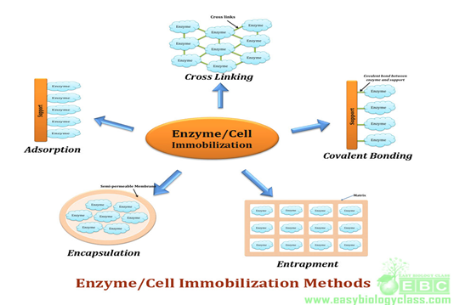

9. What are mutations? List the types and Write notes on any one. Definition: 01 mark. Any one description: 04 marks: A Mutation occurs when a DNA gene is damaged or changed in such a way as to alter the genetic message carried by that gene. A Mutagen is an agent of substance that can bring about a permanent alteration to the physical composition of a DNA gene such that the genetic message is changed. The types of mutations include: Missense mutation. This type of mutation is a change in one DNA base pair that results in the substitution of one amino acid for another in the protein made by a gene. Nonsense mutation. A nonsense mutation is also a change in one DNA base pair.
There are three types of DNA Mutations: base substitutions, deletions and insertions.
Chromosome mutations often occur due to an error in pairing during the crossing over stage of meiosis. The main types of chromosome mutation include translocation, duplication, deletion, and inversion.

10. Discuss Slurry Processing: 05 marks: A slurry is a mixture of solids denser than water suspended in liquid, usually water. The most common use of slurry is as a means of transporting solids, the liquid being a carrier that is pumped on a device such as a centrifugal pump. The size of solid particles may vary from 1 micron up to hundreds of millimeters. The particles may settle below a certain transport velocity and the mixture can behave as a Newtonian or non-Newtonian fluid. Depending on the mixture, the slurry may be abrasive and/or corrosive.

11. Describe the production of Citric acid: organism used, production- flow chart and recovery: 01+ 03+01 marks.
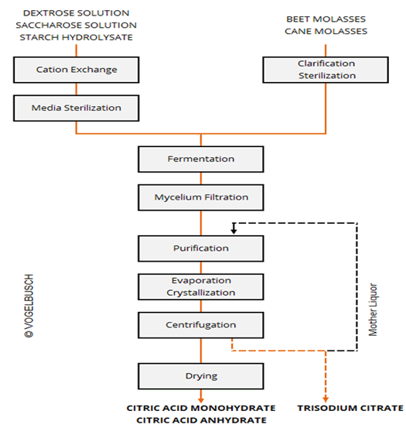

12. Discuss the production of SCP using yeast: raw material, organism used, method of production and extraction: 01+03+01 marks:
Raw materials: molasses, spent sulphite liquor, acid hydrolysate of wood, agricultural waste, whey from dairy industry, hydrolysed starchy foods, methanol, Paraffin or alkanes, petroleum fractions.
Organisms used: Saccharomyces cerevisiae, S carlsbergensis or Candida utilis(Torula yeast)
Production: Establishment of active yeast growth in fermenter, feeding of carbohydrates and sources of nitrogen, phosphorus and potassium at increasing rates until an maximal level of yeast growth is maintained. Application of optimal aeration and agitation, removal of liquor (beer) counting the yeast cells at rates and volumes equalling the additions of fresh medium.
Extraction and purification: The SCP from yeast occurs as a secondary product in the form of spent yeast. After extracting the primary products, the spent yeast-dead cells is concentrated, pasteurized and ground prior to packing.

13. Give the production of Yoghurt and its importance: production and importance: 03+02 marks: The main (starter) cultures in yogurt are Lactobacillus bulgaricus and Streptococcus thermophilus. The function of the starter cultures is to ferment lactose (milk sugar) to produce lactic acid. The increase in lactic acid decreases pH and causes the milk to clot, or form the soft gel that is characteristic of yogurt. Yogurt is a predigested food, which contains a lot of nutrients, such as carbohydrates, proteins, lipids, minerals and vitamins.
Six reasons to eat yogurt: 1. Yogurt has a similar micronutrient composition to milk, generally with a good bioavailibility and affordability, 2. Yogurt has a low energy density, 3. Yogurt is a good source of calcium and other minerals such as magnesium, potassium and zinc. It is also low in sodium. Yogurt consumers have overall a better calcium intake than non-yogurt consumers, 4. Yogurt contains B (B1, B2, B3, B6, B9 and B12), A and E vitamins, 5. Yogurt is an excellent source of high-quality proteins, whey and casein proteins, which can lead to a reduction in appetite and aid muscle and bone growth, 6. Yogurt has a higher concentration of conjugated linoleic acids than milk. Conjugated linoleic acids are reported to have immunostimulatory and anticarcinogenic properties.

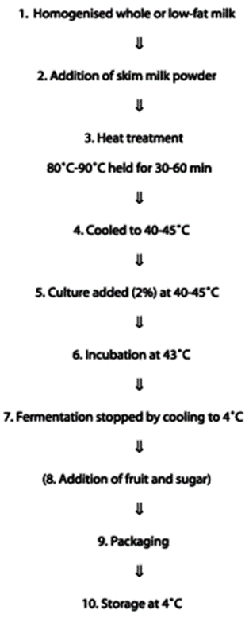

14. Write notes on the Golden rice, giving its impact and failure: formulation of golden rice, impact and failure: 01+02+02 marks: Golden rice is a variety of rice (Oryza sativa) produced through genetic engineering to biosynthesize beta-carotene, a precursor of vitamin A, in the edible parts of rice. It is intended to produce a fortified food to be grown and consumed in areas with a shortage of dietary vitamin A, a deficiency which each year is estimated to kill 670,000 children under the age of 5 and cause an additional 500,000 cases of irreversible childhood blindness. Rice is a staple food crop for over half of the world's population, providing 30–72% of the energy intake for people in Asian countries, and becoming an effective crop for targeting vitamin deficiencies.

Golden rice differs from its parental strain by the addition of three beta-carotene biosynthesis genes. The parental strain can naturally produce beta-carotene in its leaves, where it is involved in photosynthesis. However, the plant does not normally produce the pigment in the endosperm, where photosynthesis does not occur. Golden rice has met significant opposition from environmental and anti-globalization activists. A study in the Philippines is aimed to evaluate the performance of golden rice, if it can be planted, grown and harvested like other rice varieties, and whether golden rice poses risk to human health. There has been little research on how well the beta-carotene will hold up when stored for long periods between harvest seasons, or when cooked using traditional methods. In 2005, Golden Rice 2 was announced, which produces up to 23 times more beta-carotene than the original golden rice. To receive the USDA's Recommended Dietary Allowance (RDA), it is estimated that 144 g/day of the high-yielding strain would have to be eaten. Bioavailability of the carotene from golden rice has been confirmed and found to be an effective source of vitamin A for humans. Golden Rice was one of the seven winners of the 2015 Patents for Humanity Awards by the United States Patent and Trademark Office. In 2018 came the first approvals as food in Australia, New Zealand, Canada and the USA
If Golden Rice is released in to the environment, it will cause GM rice contamination and affect traditional, conventional and organic farmers. It is highly likely that rice farmers will lose their markets, especially export markets, eventually causing negative impacts on rural livelihoods. Golden rice is a variety of rice (Oryza sativa) produced through genetic engineering to biosynthesize beta-carotene, a precursor of vitamin A, in the edible parts of rice. The parental strain can naturally produce beta-carotene in its leaves, where it is involved in photosynthesis.

III. Answer any two of the following 2x10=20
15. Write detailed notes on Biosensors used in food industries: types and use: 03+07 marks: Enzyme-based biosensors can be used in food quality control to measure amino acids, amides, amines, carbohydrates, heterocyclic compounds, carboxylic acids, gases, inorganic ions, cofactors, alcohols and phenols. Biosensors can also be used in the assessment and analysis of produce such as wine, beer and yoghurt.
Types of biosensors: Electrochemical biosensors, Conductometric biosensors, Calorimetric biosensors, Potentiometric biosensors, Amperometric biosensors, Optical biosensors, Microbial biosensors, Optical microbial biosensor.

16. Discuss the process of Cell disruption by Physico-mechanical methods: methods used: 01 mark, description of any two: 09 marks:
Liquid shear, solid shear, agitation and abrasives, freeze thawing, ultrasonication.

17. Describe the production of Cheddar cheese: organism used, production-flow chart, process: 10 marks.

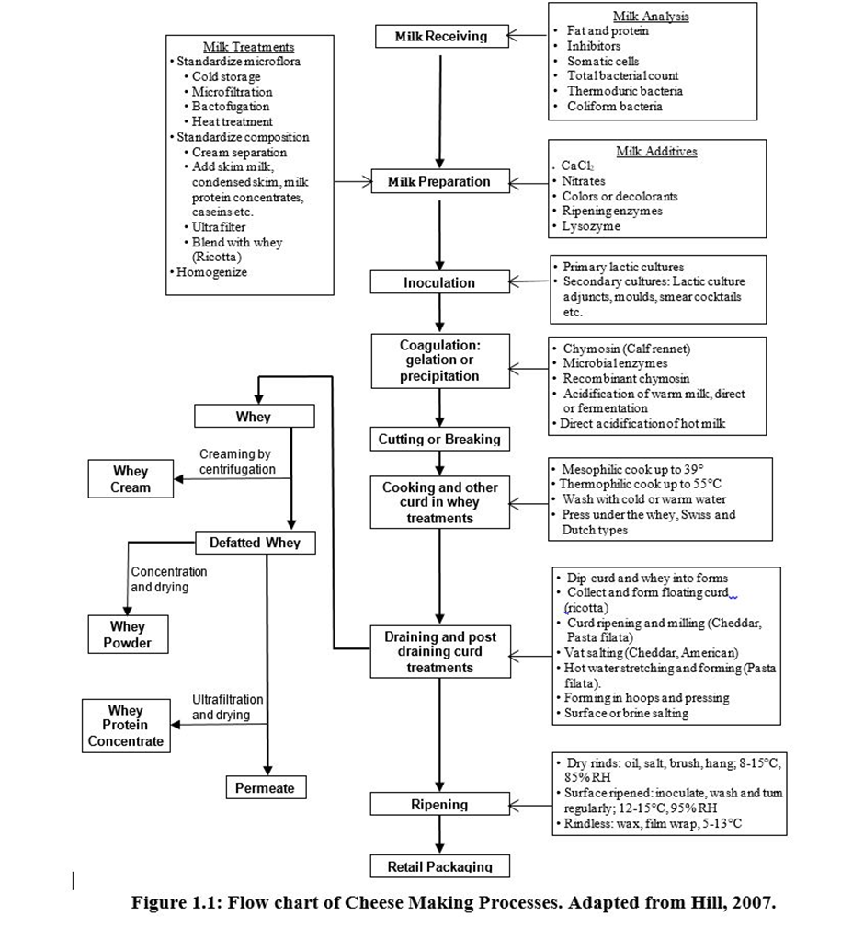

IV. Answer the following 1x10=10
18. Calgene first marketed an unsuccessful product and after which many other crops subjected to the same technology has found its way to the consumers. Identify and describe the technique used. What are its limitations and challenges? Discuss. Identification and technique used: 06 marks, limitations and challenges: 04 marks.
Genetically modified foods (GM foods), also known as genetically engineered foods (GE foods), or bioengineered foods are foods produced from organisms that have had changes introduced into their DNA using the methods of genetic engineering. GM is a technology that involves inserting DNA into the genome of an organism. To produce a GM plant, new DNA is transferred into plant cells. Usually, the cells are then grown in tissue culture where they develop into plants. The seeds produced by these plants will inherit the new DNA.Corn, Soy, Yellow Crookneck Squash and Zuccini, Alfalfa, Canola, Sugar Beets, Milk. The results of most studies with GM foods indicate that they may cause some common toxic effects such as hepatic, pancreatic, renal, or reproductive effects and may alter the hematological, biochemical, and immunologic parameters.
GM foods currently available on the international market have passed safety assessments and are not likely to present risks for human health. In addition, no effects on human health have been shown as a result of the consumption of such foods by the general population in the countries where they have been approved. Continuous application of safety assessments based on the Codex Alimentarius principles and, where appropriate, adequate post market monitoring, should form the basis for ensuring the safety of GM foods.
Like all new technologies, they also pose some risks, both known and unknown. Controversies and public concern surrounding GM foods and crops commonly focus on human and environmental safety, labelling and consumer choice, intellectual property rights, ethics, food security, poverty reduction and environmental conservation.

