Register Number:
Date:

ST. JOSEPH’S COLLEGE (AUTONOMOUS), BANGALORE-27
END SEMESTER EXAMINATION- APRIL 2020
II SEMESTER BSc/BA/BSW/BVC/BCA/BCom/BBA
AE 219 - ADDITIONAL ENGLISH

Time: 2 ½ Hours Max. Marks: 70

INSTRUCTIONS
1. This question paper contains TWO printed pages with THREE sections.
2. You will lose marks for exceeding word limits and lifting from the question paper.
3. You are allowed to use a dictionary during the examination.

I.A. Answer ANY FOUR of the following questions in about 5-8 sentences each: (4x5=20)
- “Thejaswi uses the act of ‘collecting money’ to shape the simple story of Tabara into a social satire.” Comment on this statement.
- Why is the narrative of the ‘unfaithful wife’ more pronounced in the film Shatranj ke Khiladi in comparison to the story Shatranj ke Khiladi?
- What does the ghost in Duvidha represent?
- How does the attack on Bantyappa mirror today’s political scenario?
- “Meer Sahib, save your King. If the King is lost, then you lose the game.” What is the relevance of this statement made by the narrator in the film Shatranj ke Khiladi?
I.B. Answer the following questions in about 150 words each: (2x10= 20)
- How has the filmmaker used shadow and colour in the film Duvidha symbolically? Give specific examples from the texts.
- “Satyajit Ray gives us beautiful descriptions of various animate and inanimate objects in his film.” What are some of the objects that you noticed in the film? How do they contribute to the narrative?

II. Answer ANY TWO of the following questions in about 200 words each:
(2x15= 30)
- Examine the image given below. Associate three of the various characters from the texts discussed in class this semester with this image. Validate your selection with examples.
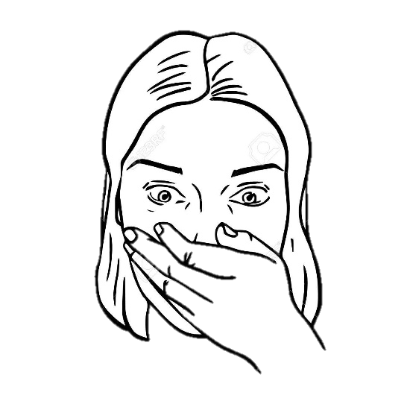
- Linda Hutcheon discusses adaptation in two ways: as a product and as a process. Pick and discuss one film from the films you’ve watched this semester that you thought was the result of a process of adaptation and not as a pre-conceived product.
- Joy Gould Boyum in Double Exposure (1985) says “Film is not presented to us directly without intervention and guidance. The camera totally controls our perceptions- determining our point of view, establishing our closeness or distance to figures and action, blurring our focus or sharpening it, selecting our angle of vision.” How has the camera controlled your understanding of the films discussed in class this semester? Give evidence to support your answer.

