**ST.JOSEPH’S COLLEGE (AUTONOMOUS), BANGALORE-27**

M.Sc. – II SEMESTER

SEMESTER EXAMINATION -APRIL 2019

**PH 8218 : Atomic and Molecular Physics**

**Time : 2½ hrs**  **Max. Marks: 70**

**PART-A**

Answer any **five** of the following: (5X10=50)

1.a)  Based on spin orbit interaction, sketch the energy levels for n=3 and n=2  states of          hydrogen atom and indicate the possible spectral transitions.

  b) Derive an expression for Lande’s splitting factor and explain the theory of anomalous          Zeeman Effect.                                                                                                      (3+7)

2.a) Give the classical theory of Raman scattering. Explain the condition for a vibration to be         Raman active taking the normal vibration of CO2 molecule as an example.

   b) Why in rotational Raman spectrum of CO2, a spacing of 8**B** is observed between         consecutive Raman lines?   (8+2)

3.a) Distinguish between symmetric top and spherical top molecules. Explain the effect of         centrifugal distortion on the rotational energy levels and spectrum of a diatomic         molecule.

   b) What is a **v**’ progression in electronic spectra of diatomic molecules? Why transitions of        **v**’ progression are of considerable intensity?                                               (7+3)

4.a) Determine the possible values of the angular momentum of an **f** electron according to          wave mechanics. Also find the angle between the vectors L and S

b) Describe the different interactions contributing to the Hamiltonian of the system giving         the ESR signal. (5+5)

5.a) Write a note on relaxation time and explain how it affects the width of spectral line. Why        is TMS selected as a reference in NMR spectra?

b) Explain the effect of quadrupole interaction on Mössbauer spectra for a system having        I =1/2 in the ground state I = 3/2 in the excited state. (6+4)

6.a) Draw the block diagram of a regenerative continuous wave oscillator arrangement to         observe NQR and give its working.

    b) The spin of 59Co nucleus is 7/2. Assuming an axial field gradient, obtain expression for         frequencies of the quadrupolar transitions. (4+6)

7.a) Explain the terms: atomic scattering factor, structure factor and geometric structure        factor.

   b) Show that reflection to appear in a diffraction experiment involving BCC crystals the        sum of the Miller indices of the scattering plane must be even. (6+4)

**PART-B**

Answer any **four** of the following: (5X4=20)

8. Calculate the wavelength separation between the normal Zeeman pattern of a spectral        line of wavelength 510 nm subjected to a magnetic field of 3T when observed in the       (i) transverse direction and (ii) longitudinal direction.

9. The fundamental and first overtone vibration transition of 14N16O are centered at     1876.06cm-1 and 3724.20cm-1 respectively. Evaluate the equilibrium vibrational     frequency, the anharmonicity constant, and force constant of the molecule.

10. The ground state electron configuration of silicon is 1s2 2s2 2p6 3s2 3p2. Find the spectral      terms for this state via L-S coupling scheme and identify that which is lowest in energy.

11. Predict the ESR hyperfine structure and obtain the frequencies when an unpaired             electron interacts with two equivalent protons.

12. Calculate the recoil velocity and energy of a free Mössbauer nucleus 57Fe*, when       emitting a γ- ray of frequency 3.5x1018 Hz. What is the Doppler shift of the γ- ray       frequency to an outside observer?

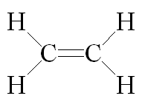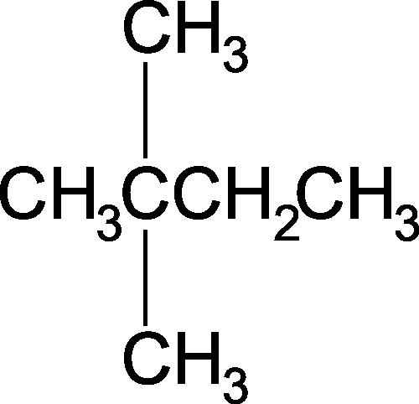13. How many signals would there be in the NMR spectrum of the following molecules?       Give reasons:

    (i) CH3CH2CH3 (ii) (iii)