
Register Number:
Date:

ST. JOSEPH’S COLLEGE (AUTONOMOUS), BANGALORE – 27
VI SEMESTER CPE: END-SEMESTER EXAMINATION: APRIL 2019
CE 6317 – Communicative English –Writing & Producing For Multimedia

Time- 2^{1/2} hrs Max Marks- 70
Instructions:

- This paper is for students of VI semester CPE who have opted for the Writing and Producing for Media elective.
- The paper has THREE SECTIONS and TWO printed pages.
- You are allowed to use a dictionary.
- Don’t exceed the word limit.

- Examine the given infographics and answer the questions below.
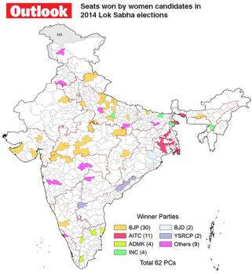
Figure 1
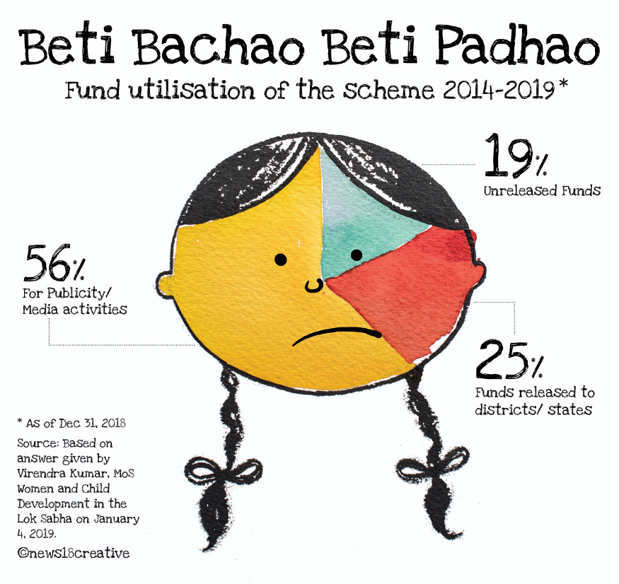
Figure 2
- Answer the following questions in 150 words each. (2x15=30)

  - Write a short article using the information provided in the 2 images. Give it an apt headline.
  - If you were making a series of such images for the upcoming elections, what would the other images show? Draw at least one other image. Give it a caption.

- You are making a video to raise funds for Meta 2020. Write a pitch in 200 words explaining what you’d like to focus on in the video, who it would target, and what you would NOT do. (20 marks)

- Answer the following questions in 100 words each. (2x10=20)
- What are some of the problems you encountered while making podcasts? What suggestions would you give to someone making a podcast for the first time?

- Write about an unexpected learning experience from your Communicative English classes in the last three years. Draw an illustration to accompany your account.

*****

