Register Number:

Date: 13-04-2019

ST JOSEPH’S COLLEGE (AUTONOMOUS), BANGLORE-27
BCA – VI SEMESTER
SEMESTER EXAMINATION APRIL-2019
CA 4215 – Computer Network-1
Time – 2 ½ hrs MaxMarks-70

PART A
I Answer the following question 2*10=20
- What is a computer network? List the different types of computer network.
- How is the switch different from hub?
- Expand CSMA, TELNET.
- List the difference between packet and frame.
- What are the different types of transmission error in networking?
- What is guided transmission media? What is the different type of guided transmission media used in networking?
- What is congestion? Name the algorithms used to control the congestion.
- Expand CRC, VRC.
- Write the differences between broadband and baseband transmission media.
- Write the advantages of DNS.

PART B
II Answer any FIVE question 6*5=30
- What is data communication? List the components of data communication.
- Explain the working of mobile telephone switching system.
- Define switching? Briefly explain circuit switching.
- Explain the working of CSMA/CD.
- With the neat diagram explain the working of select and reject ARQ
- Write a short note on fiber optics cable.
- Explain the working of electronic mail.

PART C
III Answer any TWO question 2*10=20
- Explain the different layers of OSI model.
- Using the Hamming code identify the error for the given data
Sender 1011111 receiver 1111111.
- Explain the steps involved in dijkstra’s algorithm. Illustrate with the following example.

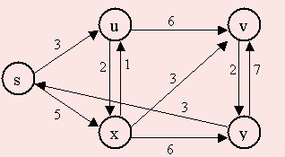

CA 4215_A_19

