Register No.:
Date:
ST. JOSEPH’S COLLEGE (AUTONOMOUS), BANGALORE-27
B.Sc. BIOTECHNOLOGY - IV SEMESTER
SEMESTER EXAMINATION: APRIL 2019
BT 415 - Molecular Biology

Time- 1 1/2 hrs Max Marks-35
This paper contains TWO printed pages and TWO parts

Part A : Answer any SEVEN of the following 7X2=14 Marks
1. In which cell cycle stages do licensing and firing of DNA replication take place in eukaryotes? Why are they separated in distinct phases of cell cycle?
2. Imagine that you are Martha Chase in 1951. You have labelled two sets of phages- one with radioactive Sulphur and one with radioactive Phosphorus. You infected two separate sets of E. coli with these two phages. Later, you separated the phage particles and E. coli by blending and centrifugation. Surprisingly, you found that E. coli cells in first set have radioactive Sulfur, and the E. coli in the second set have radioactive Phosphorus.
- What will be your conclusion from these observations?
- Just based on this experiment, which macromolecule(s) may act as the genetic material of the phage?
3. Please construct (draw) an anti-parallel DNA molecule containing two base-pairs from the given components. You can use each component multiple times. Please label the phosphodiester bonds, the glycosidic bond, and the hydrogen bonds.
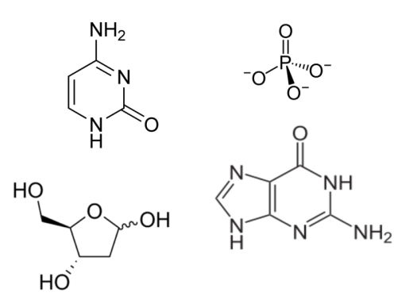
4. Which DNA damage response process involves a transcriptional repressor? Name the transcriptional repressor and describe its main role in two sentences.
5. Name a step in the production of proteins that takes place in Golgi body. Give a specific example.
6. Write a very specific function of the sigma factor during prokaryotic transcription.
7. How is degeneracy of the genetic code relevant to the central dogma?
8. A promoter is high methylated. What would be the transcription status of the gene associated to this promoter? Give a suitable reason.
9. List the major components of the promoter for RNA polymerase I.
10. What would happen if the Lac repressor is always active?

Part B Answer any THREE of the following 3x7=21 Marks
11. Answer the following questions about polyA tail with specific details:
- What is a polyA tail? Where is it found? (2 sentences)
- Explain the steps in generation of a polyA tail. Include the sequences, proteins, and enzymes essential for this process and their specific roles.
- What all may be the consequences of removing polyA tails from an mRNA in a cell?
12. Scientists recently found a very unusual eukaryote. This organism has a DNA polymerase that can initiate DNA synthesis without the need for a pre-existing 3’OH. Which three enzymes involved in DNA replication of other eukaryotes will not be required in this organism? Why?
13. Answer the following questions about mutations:
- Can mutations happen without any external agent? How?
- Name three agents that can cause mutations and the specific type of DNA damage caused by them.
14. Differentiate between eukaryotic and prokaryotic transcription initiation.
15. Describe the process of prokaryotic aminoacylation of tRNA in detail. How do the two classes of aminoacyl tRNA synthetase differ from each other in their function?

